JSS MAHAVIDYAPEETHA
JSS Science and Technology University

Certificate of Plagiarism Check
Certificate of Plagiarism Check This is to certify that the work entitled This is to certify that the project report entitled “A data-driven framework for diabetic peripheral neuropathy risk prediction using foot thermograms” has been evaluated using the Turnitin plagiarism checker and is reported to have a similarity index of 14% which is below the university agreed norms.

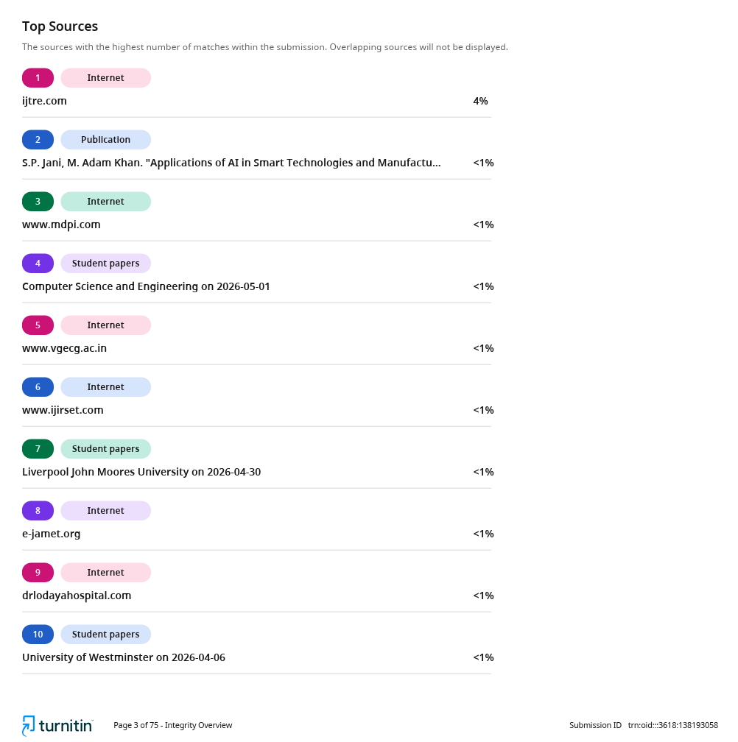

DECLARATION
We do hereby declare that the project titled “A data-driven framework for diabetic peripheral neuropathy risk prediction using foot thermograms” is carried out by Prajwal T P (01JST21CS099), Agasthya Samyak Jnan (02JST22UCS006), Arvind Ningombam (02JST22UCS017), Jayanth S (02JST22UCS043), under the guidance of Amaresh A M, Assistant Professor, Department of Computer Science and Engineering, JSS Science and Technology University, Mysuru, in partial fulfilment of requirement for the award of Bachelor of Engineering by JSS Science and Technology University, Mysore, during the year 2025-2026.
We also declare that we have not submitted this dissertation to any other university for the award of any degree or diploma courses.
Date:
Place: Mysore
Agasthya Samyak Jnan (02JST22UCS006)
Jayanth S (02JST22UCS043)
Arvind Ningombam (02JST22UCS017)
Prajwal T P (01JST21CS099)

ACKNOWLEDGEMENT
An endeavor is successful only when it is carried out under proper guidance and blessings. We would like to thank a few people who helped us in carrying this work by lending invaluable assistance.
We express our sincere regards to His Holiness Jagadguru Sri Shivaratri Deshikendra Mahaswamiji who has showered his blessings on us for framing our career successfully. We hereby thank Dr. C Nataraju, (i/c) Principal, SJCE, JSSTU, Mysuru and Dr. Anil Kumar K M, Head Of the Department, Department of Computer Science and Engineering, SJCE, JSSTU, Mysuru who encouraged us at this venture.
It is our foremost duty to thank our project supervisor Amaresh A M for his encouragement, effective guidance and valuable suggestions right from the beginning of this project till its completion. We thank panel members for their support and guidance throughout the project and during CIE. We also extend our regards to all the teaching and non-teaching members of the Department of Computer Science and Engineering for their direct or indirect support towards the completion of this project. We would also like to thank our family and friends for their constant support.

ABSTRACT
Diabetic Peripheral Neuropathy (DPN) is one of the most common and severe complications associated with diabetes mellitus. If left undetected, it can lead to serious conditions such as foot ulcers, infections, and even lower limb amputations. Early detection of neuropathy is therefore essential for preventing disease progression and improving patient outcomes. This project presents a data-driven and non-invasive framework for predicting diabetic neuropathy risk using plantar foot thermograms. Infrared thermography captures the temperature distribution across the foot surface, which reflects underlying physiological conditions such as blood flow abnormalities, inflammation, and nerve damage. These thermal patterns serve as key indicators for early neuropathic changes. The proposed system combines deep learning and statistical feature extraction techniques to analyse thermal images. A pretrained MobileNetV2 model is used to extract deep convolutional features, while handcrafted thermal descriptors such as mean temperature, standard deviation, and entropy are computed to capture interpretable characteristics of thermal distribution. These features are fused to form a hybrid representation, which is used to compute a Thermal Risk Score (TRS). The TRS quantifies the severity of abnormal thermal patterns and is further utilized for classification using an XGBoost model. To enable multi-level risk categorization, K-Means clustering is applied to group samples into Low, Medium, and High-risk categories. Experimental results demonstrate that the hybrid model significantly outperforms standalone deep learning approaches by improving prediction accuracy and interpretability. A desktop-based application is also developed to provide real time risk prediction, highlighting the practical applicability of the system. Overall, the proposed framework provides an efficient, scalable, and interpretable solution for early screening of diabetic neuropathy, making it suitable for use in healthcare environments with limited resources.
TABLE OF CONTENTS

Contents | Page No
Acknowledgement  Abstract  Table of Contents  List of Figures  List of Tables  - INTRODUCTION  1.1 Problem Statement  1.2 Aims and Objectives  1.3 Existing Solutions  1.4 Proposed Solutions  1.5 Applications  - LITERATURE REVIEW  2.1 Review of Existing Work  2.2 Comparative Analysis  2.3 Research Gap  2.4 Limitations of Current Work  - PRESENT WORK BEING CARRIED OUT  3.1 System Requirements and Design  3.2 Dataset Overview and Preprocessing  3.3 CNN based Feature Extraction  3.4 Thermal Features Extraction  3.5 Hybrid Features Representation  3.6 Dataset Risk Labelling and Thermal Risk Score  3.7 Risk Modelling and Classification  3.8 Tools and Technologies  3.9 System Implementation  - RESULTS AND DISCUSSIONS  4.1 CNN Model Performance Results  4.2 Data Risk Labelling Analysis  4.3 Risk Prediction Results  - CONCLUSIONS  APPENDIX A - Project Team Details  APPENDIX B - COs, POs and PSOs mapping for the project work  REFERENCES | i  ii  iii  iv  v  2  5  6  8  9  13  15  17  18  19  21  23  24  25  26  27  30  35  44  45  49  54  55  56  61

LIST OF FIGURES

Fig No. | Figure Title | Page No.
Fig 1.1.1  Fig 1.1.2  Fig 1.1.3  Fig 1.1.4  Fig 1.3.1  Fig 1.3.2  Fig 3.1.1  Fig 3.2.1.1  Fig 3.3.1  Fig 3.7.4.1  Fig 3.8.1.1  Fig 3.8.2.1  Fig 3.8.3.1  Fig 3.8.3.2  Fig 3.8.4.1  Fig 3.8.5.1  Fig 3.8.6.1  Fig 3.8.6.2  Fig 3.9.5.1  Fig 3.9.5.2  Fig 3.9.5.3  Fig 3.9.5.4  Fig 3.9.5.5  Fig 3.9.5.6  Fig 3.9.5.7  Fig 3.9.5.8  Fig 3.9.5.9  Fig 3.9.5.10  Fig 3.9.5.11  Fig 4.1.1  Fig 4.1.2 | Stages of Diabetic Neuropathy  Callus Formation due to Diabetic Neuropathy  Ulcer Formation due to Diabetic Neuropathy  Healthy Foot and Foot under Diabetic Peripheral Neuropathy  Available treatment methods for Diabetic Neuropathy  Medicines for Diabetic Peripheral Neuropathy as per WHO guidelines  Overall System Architecture  Samples from augmented dataset corresponding to neuropathic risk : Low risk, Medium risk and High risk foot images  MobileNetV2 CNN Backbone Architecture  XGBoost Model Architecture  Python  Tensorflow and Keras  NumPy  OpenCV  Scikit-Learn  Matplotlib  Google Colab  Visual Studio Code  Overall Application Structure containing models and scripts  Models directory containing trained MobileNetV2, XGBoost models and StandardScaler artifact  Requirements file for setting up environment for the application  Opening Interface of the Diabetic Neuropathy Risk Predictor Application  Application giving a warning message for using predict option when no images are uploaded  Thermal image file selection menu after pressing the upload button in Application  Application interface showing uploaded image preview  Application interface showing uploaded image preview as heatmap  Application showing prediction output with colour highlighted text, progress bar, and a color graph for Low Risk category image  Application showing prediction output with colour highlighted text, progress bar, and a color graph for Medium Risk category image  Application showing prediction output with colour highlighted text, progress bar, and a color graph for High Risk category image  Accuracy Plots of Training of MobileNetV2 based Classifier Model.  Accuracy Plots of Fine Tuning of MobileNetV2 based Classifier Model. | 2  3  3  4  6  7  20  21  23  28  31  31  32  32  33  33  34  34  39  39  39  40  40  40  41  41  42  42  43  45  45

LIST OF TABLES

Table No. | Table Title | Page No.
Table 2.1  Table 4.1  Table 4.3.1  Table 4.3.2  Table 4.3.3  Table 4.3.4  Table 4.3.1.1 | Literature Overview  Comparison of performance of different Pre-trained CNN backbones.  Confusion Matrix for results of XGBoost model for hybrid input features  Performance metrics for results of XGBoost model for hybrid input features  Confusion Matrix for results of XGBoost model for CNN-only input features  Performance metrics for results of XGBoost model for CNN-only input features  Comparing performance of XGBoost model with inputs having CNN features only and Hybrid features | 11  44  49  49  51  51  52

CHAPTER 1
INTRODUCTION
Diabetes mellitus is a chronic metabolic disorder that affects a significant portion of the global population. It is primarily characterized by elevated blood glucose levels caused by insufficient insulin production or ineffective insulin utilization. Over time, prolonged hyperglycemia leads to several complications affecting multiple organ systems. Among these, Diabetic Peripheral Neuropathy (DPN) is one of the most common and serious complications.
Diabetic Peripheral Neuropathy is a condition that results in damage to the peripheral nerves, especially in the lower extremities such as the feet. Patients suffering from DPN often experience symptoms including numbness, tingling sensations, burning pain, and loss of protective sensation. This eventually leading to severe complications such as foot ulcers, infections, and in extreme cases, lower limb amputations.
Early detection of neuropathy is essential to prevent disease progression and reduce healthcare burden. However, traditional diagnostic methods such as nerve conduction studies and physical examinations are often time-consuming, expensive, and not suitable for large-scale screening. In recent years, infrared thermography has emerged as a promising non-invasive technique for detecting early signs of neuropathy. Thermal imaging captures the temperature distribution across the foot surface, which reflects underlying physiological conditions such as inflammation, blood flow irregularities, and nerve damage.
Advancements in machine learning and deep learning have enabled automated analysis of medical images with improved accuracy and efficiency. By leveraging these techniques, it is possible to detect subtle thermal abnormalities that may not be easily identifiable through manual inspection. This project aims to utilize thermal imaging and machine learning techniques to develop an automated system for predicting diabetic neuropathy risk.

1.1 PROBLEM STATEMENT
Diabetic peripheral neuropathy (DPN) is a serious and progressive complication of diabetes mellitus that affects the peripheral nerves, particularly in the lower extremities such as the feet. It leads to symptoms including numbness, tingling, burning sensations, and loss of protective sensation. As the condition progresses, patients may become unable to perceive pain or pressure, which significantly increases the risk of unnoticed injuries. These injuries can develop into severe complications such as foot ulcers, infections, and, in extreme cases, lower limb amputations. Due to its gradual onset and subtle early symptoms, DPN often remains undiagnosed until it reaches an advanced stage.
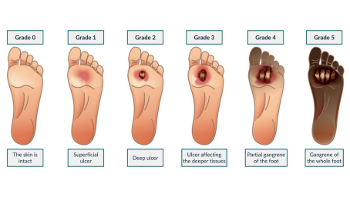
Fig 1.1.1 Stages of Diabetic Neuropathy
Early detection of neuropathy is essential to prevent complications and improve patient outcomes. However, identifying early-stage neuropathic changes is challenging because the symptoms may not be clearly visible or easily measurable using conventional observation. The physiological changes associated with neuropathy, such as inflammation, impaired blood circulation, and nerve dysfunction, often manifest as variations in skin temperature distribution, especially on the plantar surface of the foot.

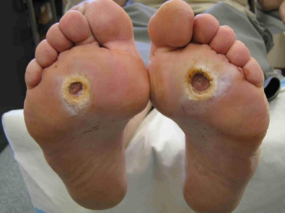
Fig 1.1.2 Callus Formation due to Diabetic Neuropathy
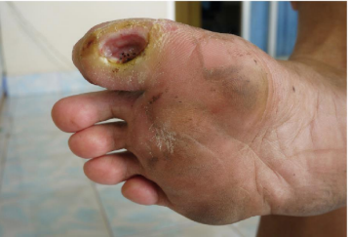
Fig 1.1.3 Ulcer due to Diabetic Neuropathy
Infrared thermography provides a non-invasive method to capture these temperature variations in the form of thermal images. These thermograms contain valuable information about underlying physiological conditions, but analysing them accurately is a complex task. The temperature distribution across the foot is influenced by multiple factors, and abnormal patterns are often subtle and difficult to interpret visually. This makes it challenging to reliably identify early signs of neuropathy using manual inspection alone.
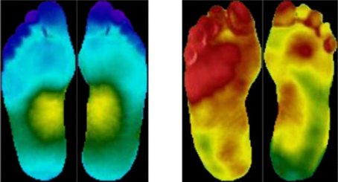
Fig 1.1.4 (a) Healthy Foot (b) Foot under Diabetic peripheral neuropathy

Moreover, thermal patterns associated with neuropathy are not uniform across individuals and can vary depending on several conditions such as environment, imaging setup, and individual physiological differences. This variability adds further complexity to the problem and requires a robust analytical approach capable of identifying meaningful patterns from thermal data.
Therefore, the core problem addressed in this project is the development of an effective system capable of analyzing plantar thermal images to detect and quantify neuropathic risk. The system must be able to capture complex thermal variations, interpret underlying physiological abnormalities, and provide a meaningful representation of risk levels. Solving this problem will enable early identification of neuropathy, support timely intervention, and contribute to reducing severe diabetic foot complications.

1.2 AIM AND OBJECTIVES
The development of an effective system for diabetic neuropathy risk prediction requires a clear definition of its overall aim and the specific objectives that guide its implementation. This section outlines the primary goal of the project along with the individual objectives designed to achieve it.
1.2.1 AIM
The aim of this project is to design and develop a non-invasive, data-driven system for predicting diabetic neuropathy risk using plantar thermal images by integrating machine learning and deep learning techniques. The system focuses on analyzing thermal patterns of the foot to identify underlying physiological abnormalities and provide a meaningful assessment of diabetic neuropathy risk.
1.2.2 OBJECTIVES
To achieve the above aim, the following objectives are defined:
- To develop a deep learning model capable of extracting meaningful and discriminative features from thermographic images.
- To compute statistical thermal features such as mean temperature, standard deviation, and entropy to capture the distribution and irregularities in thermal patterns.
- To design a hybrid feature representation by combining deep learning features with statistical thermal descriptors.
- To formulate a Thermal Risk Score (TRS) that quantifies the severity of thermal abnormalities associated with neuropathy.
- To implement a machine learning model for predicting neuropathy risk based on the extracted hybrid features.
- To evaluate the performance of the proposed system using appropriate metrics and validate its effectiveness.

- To develop a user-friendly interface for practical application and real-time prediction of neuropathy risk.
These objectives collectively ensure the development of a system that is accurate, interpretable, and suitable for real-world screening and monitoring of diabetic neuropathy.
1.3 EXISTING SOLUTIONS
Various methods have been developed over the years for the detection and assessment of diabetic peripheral neuropathy. These approaches aim to identify nerve damage and associated complications at different stages of the disease. Broadly, the solutions can be categorized into clinical examination techniques and technology-based approaches.
Traditional clinical methods include physical examinations that assess nerve sensitivity and foot condition. These methods typically evaluate parameters such as pressure sensation, vibration perception, and reflex responses. While such techniques are widely used in medical practice, they are often dependent on the skill and experience of healthcare professionals. In addition, these methods may not always be effective in detecting early-stage neuropathy, as the symptoms may not be sufficiently pronounced.

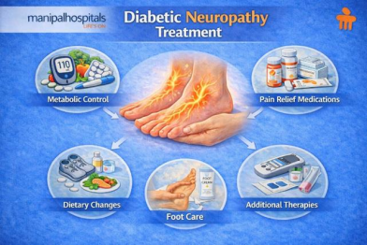
Fig 1.3.1 Available treatment methods for Diabetic Neuropathy
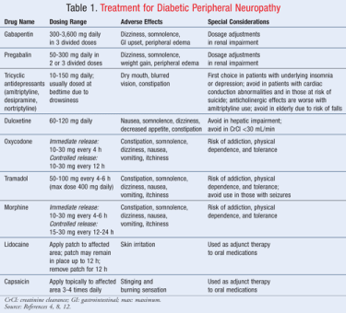
Fig 1.3.2 Medicines for Diabetic Peripheral Neuropathy as per WHO guidelines

With advancements in medical imaging, thermography has gained attention as a non-invasive technique for analyzing temperature distribution on the foot. Thermal imaging helps in identifying abnormal heat patterns that may indicate inflammation, poor blood circulation, or nerve dysfunction. These thermal patterns are considered important indicators of potential neuropathic changes.
In recent years, computational approaches have been introduced to improve the analysis of thermal images. Image processing techniques have been used to extract temperature-related features and analyze asymmetry between different regions of the foot. These methods aim to identify deviations from normal thermal distribution that may be associated with neuropathy.
Furthermore, machine learning and deep learning techniques have been applied to automate the analysis process. Models based on image classification and pattern recognition have been developed to identify abnormal thermal patterns and assist in risk prediction. These approaches leverage data-driven techniques to improve detection accuracy and reduce reliance on manual interpretation.
Despite these developments, challenges remain in effectively analyzing complex thermal patterns and translating them into meaningful clinical insights. The diversity of thermal characteristics across individuals and variations in imaging conditions add to the complexity of the problem.
1.4 PROPOSED SOLUTION
To address the challenges associated with the analysis of thermal foot images and the accurate assessment of diabetic neuropathy risk, this project proposes a comprehensive and systematic approach based on the integration of deep learning and statistical feature analysis. The proposed solution focuses on developing a non-invasive, data-driven framework capable of capturing complex thermal patterns and translating them into meaningful risk indicators.
The system begins with the acquisition of plantar thermal images, which are then subjected to preprocessing steps such as resizing and normalization to ensure consistency across the dataset. These standardized images are used as inputs for further analysis. The preprocessing stage plays a crucial role in reducing noise and variability, thereby improving the reliability of subsequent feature extraction processes.

In the next stage, a deep learning model is utilized to extract high-level features from the thermal images. A pretrained convolutional neural network is employed to capture spatial patterns and subtle variations in temperature distribution that may be associated with neuropathic changes. These deep features provide a robust representation of the thermal characteristics present in the images.
Alongside deep feature extraction, statistical thermal features are computed to capture interpretable aspects of the temperature distribution. These features include measures such as mean temperature, standard deviation, and entropy, which collectively describe the intensity, variability, and irregularity of thermal patterns. Such descriptors help in identifying abnormal physiological conditions that may not be explicitly represented by deep learning features alone.

The extracted deep features and statistical features are then combined to form a hybrid feature representation. This fusion approach leverages the strengths of both methods, ensuring that the model benefits from both high-level pattern recognition and interpretable thermal characteristics. The hybrid feature vector provides a more comprehensive understanding of the underlying data.
To quantify the severity of thermal abnormalities, a Thermal Risk Score (TRS) is computed using a weighted combination of key statistical features. This score serves as a continuous indicator of neuropathy risk and reflects the degree of deviation from normal thermal patterns.
A machine learning model is then used to predict the risk level based on the hybrid feature representation. The predicted risk is further categorized into multiple levels, such as low, moderate, and high risk, to facilitate easier interpretation and decision-making. This multi-level classification approach provides more detailed insights compared to simple binary outcomes.
Finally, the proposed system is implemented as a user-friendly application that allows users to upload thermal images and obtain real-time risk predictions. This enhances the practical usability of the system and demonstrates its potential for deployment in clinical and remote healthcare environments.
1.5 APPLICATIONS
The proposed system for predicting diabetic neuropathy risk using plantar thermal images has a wide range of applications in the healthcare domain. Its non-invasive nature, cost-effectiveness, and ability to provide early risk assessment make it suitable for various real world scenarios. The key applications of the system are described below.
One of the primary applications is in clinical screening, where the system can be used as an initial assessment tool in hospitals and diagnostic centers. It can assist healthcare professionals in identifying patients who are at risk of developing diabetic neuropathy, enabling early intervention and reducing the likelihood of severe complications.

The system can also be applied in preventive healthcare, where individuals with diabetes can regularly monitor their foot health. By detecting early thermal abnormalities, patients can take timely precautions regarding their conditions.
Another important application is in remote healthcare and telemedicine. The system allows thermal images to be captured and analyzed without requiring the physical presence of a specialist. This is particularly beneficial for patients in rural or underserved areas, where access to advanced medical facilities may be limited.
The proposed framework can also be used for continuous monitoring of disease progression. By analyzing thermal images over time, the system can track changes in neuropathy risk levels, helping clinicians evaluate treatment effectiveness and make informed decisions regarding patient care.
In addition, the system is useful in resource-limited healthcare environments, as it reduces dependence on expensive diagnostic equipment and specialized procedures. Its lightweight and automated nature make it suitable for local deployments.
Finally, the integration of the system into a domestic-based application demonstrates its potential for real-time decision support, improving efficiency and enabling faster response to potential complications.

CHAPTER 2
LITERATURE REVIEW
Author(s), Year | Methodology | Key Findings | Limitations
Panamonta et al., 2025 | CNN-based risk classification | Lightweight CNNs enable potential clinical deployment | Limited clinical validation
Ma Y., 2025 | Systematic review of ML techniques for DPN | Reviewed ML models, datasets, limitations, and research trends; identified lack of imaging and thermal datasets | No experimental validation; conclusions depend on availability and quality of existing studies
Shig G. et al., 2025 | ML risk prediction (RF, DT, etc.) with SHAP explainability | Provided comparative performance analysis of ML models with explainability | Does not incorporate medical imaging; limited external validation
Evangeline et al., 2024 | Deep CNN models | High accuracy in diabetic foot risk prediction | Small dataset size; limited generalization
Wu et al.,2024 | Hybrid ML–DL approaches | Combining thermal features with deep models improves classification accuracy | Lack of standardized acquisition protocols
Frontiers in Neuroscience, 2024 | ML classifiers (AdaBoost, SVM) | Demonstrated potential for non-invasive, continuous neuropathy monitoring | Requires wearable hardware; lacks imaging-based biomarkers
Frontiers in Neuroscience, 2024 | Transformer-based deep learning classifier using CCM | Improved classification performance using transformer architecture | Computationally expensive; requires large datasets
Cao et al., 2023 | Plantar region segmentation + feature extraction | Region-wise analysis improves sensitivity to neuropathic changes | Segmentation errors affect downstream classification
Khandakar et al., 2022 | Thermal Change Index (TCI) + ML classifiers (SVM, RF) | Handcrafted thermal indices effectively discriminate diabetic and non-diabetic feet; high interpretability | Relies on engineered features; limited deep feature learning
Preston F. G. et al., 2022 | End-to-end deep learning model using CCM | Achieved high diagnostic accuracy without manual segmentation | Limited to a single imaging modality; lacks cross-modal validation
Alam U. et al., 2022 | AI-assisted DPN diagnosis | Highlighted automated nerve damage metrics and AI sensitivity in subclinical neuropathy | Conceptual focus; lacks thermogram-based experimental validation
Khandakar A. et al., 2021 | CNN-based classification using dual-foot images | Demonstrated superior performance using bilateral foot thermograms | Limited dataset size; focused on ulcer prediction rather than explicit neuropathy risk
Table 2.1 Literature Overview

2.1 Review of Existing Work
Diabetic neuropathy related foot ailments have already been studied widely. Their rate of occurrence among diabetic patients is high and there are high chances of them leading to ulcers and amputations and such foot disease cases are well documented [16]. This shows that there is need for early identification strategies [12], [19]. Many international committees have provided many rules, regulations and recommendations for better handling diabetic foot problems [13], [20].
Lavery et al. [1] demonstrated that consistent monitoring of plantar skin temperature significantly helped take measures to reduce ulcers and findings established clinical importance of temperature asymmetry and localized thermal elevation as useful indicators. Bharara et al. [14] and Yavuz et al. [15] further support role of plantar temperature monitoring in avoiding diabetic foot problems.
We preferred thermographic imaging as input for our work because its an easy, contactless and economic method to assess diabetic foot as compared to other methods, with studies demonstrating its effectiveness in ulcer assessment [17]. Bagavathiappan et al. [2] showed that plantar thermal patterns relate to diabetic neuropathy, showing thermal imaging modality to be a promising tool for detecting such patterns. Balbinot et al. [3] confirms consistent results with standardized acquisition protocols for thermal images. Also, van Netten et al. [4] investigated identifying diabetic foot problems through thermographic imaging which showed its feasibility in clinical screening. A Foot thermogram database for study diabetic foot problems was given by Hernández Contreras et al. [5].
Khandakar et al. [6] proposed the Thermal Change Index (TCI) which mixes temperature-based descriptors with statistical classification algorithms and their work shows that engineered thermal indices diabetic and non-diabetic identify with strong interpretability. Thus, their study inspired composite feature modeling of thermograms in this work. Castillo-Morquecho et al. [7] used machine learning techniques with thermography for diabetic foot assessment and highlighted importance of using thermal descriptors. A review of machine learning-aided thermal imaging systems by Wu et al. [8] showed shift of manually engineered features towards more hybrid approaches.
Using deep learning image models like MobileNetV2 [9] make for efficient systems, keeping good representational power for lightweight screening systems. Also, current studies have limitations like many thermography-based method do just ulcer detection but not measuring probable neuropathy risk. Clinically calibrated temperature thresholds are used in some systems that may not generalize in all acquisition methods.
Some deep learning systems give good classification accuracy without using interpretable thermal characteristics [8]. There remains a need for lightweight, interpretable, and data-driven frameworks for categorizing risk levels without depending over strict temperature limits.
In deep learning-based approaches, we usually have less understanding on what features contribute to different indicators of diabetic foot problems. Systems that combine many features together, they help us interpret these features in a better way.
Many augmentation techniques on dataset improve generalization while using limited medical datasets [11]. XGBoost [10] like ensemble models showed strong performance in structured feature classification.
This study proposes a Thermal Risk Score (TRS) framework for neuropathy risk prediction based on clinical relevance of plantar thermography [1]-[4], and composite thermal feature modeling approaches [6].
Global mean intensity, temperature variability, and entropy are included in the proposed system as skin temperature variations have been shown to correlate with underlying tissue characteristics in diabetic patients [18]. These all together are then converted to a composite score. Risk categories are done using unsupervised clustering enabling adjustments to demographic anomalies.
This work tries to bridge the gap from deep learning-based models to conventional thermal asymmetry-based monitoring by proposing a lightweight system that combines both image and thermal features for better risk assessment.

2.2 Comparative Analysis
A comparative analysis of the existing methods for Diabetic Neuropathy detection highlights the evolution from traditional techniques to advanced machine learning and deep learning approaches. Each method offers specific advantages while also presenting certain limitations.
2.2.1 Traditional Machine Learning Approaches
Earlier methods relied on handcrafted features such as temperature distribution, asymmetry, and indices like the Thermal Change Index (TCI). These features were used with classifiers like Support Vector Machines (SVM) and Random Forests.
Advantages :
- High interpretability
- Lower computational requirements
- Suitable for small datasets
Limitations :
- Limited feature representation
- Reduced accuracy compared to deep learning
- Dependence on manual feature engineering
2.2.2 Deep Learning-Based Approaches
Recent studies have utilized Convolutional Neural Networks (CNNs) and transformer-based models to automatically learn features from thermal images.
Advantages :
- High accuracy and performance
- Automatic feature extraction
- Ability to capture complex patterns

Limitations :
- Requires large datasets
- Computationally expensive
- Limited interpretability
2.2.3 Hybrid Approaches (ML + DL)
Hybrid models combine deep learning features with handcrafted thermal features to improve performance and interpretability.
Advantages:
- Balanced accuracy and interpretability
- Improved robustness
- Utilizes both statistical and spatial information
Limitations:
- Increased system complexity
- Requires careful feature fusion
- Higher implementation effort
2.2.4 Thermography-Based Systems
Infrared thermography has been widely adopted as a non-invasive diagnostic tool for neuropathy detection.
Advantages :
- Non-invasive and safe
- Enables early detection
- Captures physiological abnormalities

Limitations :
- Lack of standardized imaging protocols
- Sensitive to environmental conditions
- Limited availability of labelled datasets
2.3 Research Gap
Despite significant advancements in the detection of Diabetic Neuropathy using machine learning and thermography, several limitations and unresolved challenges still exist in current research.
One major gap is that many existing studies focus primarily on binary classification (diabetic vs non-diabetic), rather than providing multi-level risk assessment such as low, moderate, and high risk. This limits their usefulness in real-world clinical decision-making, where graded risk prediction is more meaningful.
Another key issue is the limited availability of high-quality and standardized thermal datasets. Most models are trained on small or non-uniform datasets, which affects their generalization capability and reliability when applied in practical scenarios.
Additionally, many deep learning approaches rely on complex and computationally intensive architectures, making them unsuitable for deployment in resource-constrained environments such as small clinics or mobile-based healthcare systems.
There is also a lack of standardized preprocessing and imaging protocols, leading to inconsistencies in thermal image acquisition and affecting model performance across different studies.
Furthermore, although deep learning models achieve high accuracy, they often suffer from low interpretability, making it difficult for clinicians to trust and understand the predictions. On the other hand, traditional methods are interpretable but lack sufficient accuracy.

Another important gap is the limited integration of hybrid approaches that combine deep learning features with physiologically meaningful thermal indicators, which could improve both performance and interpretability.
2.4 Limitations of Present Work
The proposed system for predicting Diabetic Neuropathy using thermal foot image analysis and machine learning demonstrates promising results; however, it is subject to several limitations.
One of the primary limitations is the dependence on dataset size and quality. The model is trained on a limited dataset, which may not fully capture the variability present in real-world clinical conditions. This can affect the generalization capability of the system when applied to unseen data.
Another constraint is the lack of standardized thermal image acquisition protocols. Variations in environmental conditions, camera specifications, and patient positioning can influence thermal readings, potentially impacting the consistency and reliability of predictions.

CHAPTER 3
PRESENT WORK CARRIED OUT
3.1 System Requirements and Design
3.1.1 System Requirements
The proposed system is designed to analyze thermal foot images and produce a risk classification output. From a functional perspective, the system must be capable of loading thermal image datasets, performing preprocessing and augmentation, training deep learning models, extracting relevant thermal features, and computing a final risk score.
The primary functional requirements include:
- Importing and organizing thermal foot image datasets.
- Applying data augmentation techniques to enhance dataset diversity.
- Preprocessing input images by resizing and normalization.
- Training binary CNN classifiers to distinguish between control and diabetic thermal patterns and extract deep mathematical features from images.
- Extracting global thermal features from images.
- Computing a continuous risk score and mapping it to discrete risk levels.
In addition to functional requirements, several non-functional requirements guide system design. The system must be computationally efficient, as it is implemented and tested on limited-resource environments such as Google Colab. Reproducibility and modularity are essential to ensure that experiments can be repeated and extended.
From an analytical standpoint, the system emphasizes ethical deployment by explicitly avoiding medical diagnosis. Instead, it frames outputs as risk indicators, aligning with responsible AI practices in healthcare. This design choice ensures that the system serves as a decision-support tool rather than a replacement for clinical expertise.

3.1.2 System Design
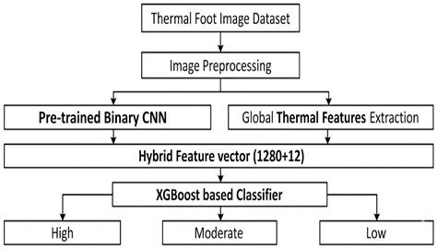
Fig 3.1.1 Overall System Architecture
This proposed system follows a multi-stage hybrid framework combining deep learning and interpretable thermographic modeling. The pipeline consists of Image preprocessing and augmentation, CNN-based deep feature learning, Statistical thermal feature extraction, Feature fusion, XGBoost classification, Thermal Risk Score (TRS) computation, K-Means based risk stratification.
The system design follows a modular pipeline architecture that processes thermal images from acquisition to final risk classification. The first stage involves dataset acquisition and augmentation, where various transformations are applied to improve robustness and generalization.
Next, image preprocessing standardizes all inputs by resizing images to a fixed resolution of the size 224 x 224 and normalizing pixel values where necessary. The preprocessed images are then fed into a binary pre-trained CNN classifier trained to identify abnormal thermal patterns associated with diabetic conditions.
In parallel, global thermal features are extracted from the same images. Feature normalization ensures consistency.
The deep features from CNN output and normalized thermal features are combined using a weighted risk score formulation. Finally, the continuous risk score is mapped into low, moderate, or high-risk categories.
3.2 Dataset Overview and Preprocessing
3.2.1 Dataset Overview
Plantar thermograms from the publicly available IEEE Dataport plantar thermogram dataset and its Kaggle mirror version were used in this work. The source dataset has bilateral thermal foot images divided into non-diabetic (control) and diabetic subjects.
The split distribution is:
- Training set: 720 Control, 724 Diabetes affected (DM) - 1444 training images
- Validation set: 170 Control, 252 Diabetes affected (DM) - 422 validation images
After applying the augmentation pipeline independently to both subsets, the dataset expanded to:
- 21,660 training images
- 6,330 validation images
Only thermographic image data was used. No clinical metadata was used. All thermographic image data is in RGB-based image format.

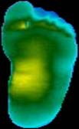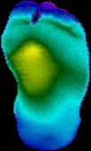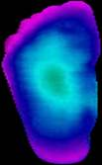
(a) (b) (c)

Fig. 3.2.1.1 Samples from augmented dataset corresponding to neuropathic risk (a) Low risk (b) Medium risk (c) High risk foot images

3.2.2 Dataset Preprocessing
This stage focuses on preparing thermal foot images for effective training and analysis in the proposed system for Diabetic Neuropathy risk prediction. Proper preprocessing ensures consistency, improves model performance, and reduces noise in the dataset.
Initially, the thermal image dataset is collected and organized into structured directories for training and validation. Since raw images may vary in size, resolution, and quality, preprocessing is applied to standardize the inputs.
The key preprocessing steps include:
- Image Resizing:
All images are resized to a fixed resolution (e.g., 224 × 224 pixels) to match the input requirements of CNN models such as MobileNetV2.
- Normalization:
Pixel values are scaled to a standard range (typically 0 to 1) to ensure uniform intensity distribution and stable model training.
- Data Augmentation:
To overcome limited dataset size and improve generalization, augmentation techniques are applied, including:
- Rotation
- Horizontal and vertical flipping
- Spatial perturbations like translation, zooming etc.
- Intensity Variations
These transformations help the model learn robust features under different variations.
- Dataset Splitting:
The dataset is divided into training and validation sets to evaluate model performance and prevent overfitting.
- Batching and Shuffling:
Data is processed in batches and shuffled randomly to improve training efficiency and reduce bias.
Images were loaded in RGB format (3-channel input) for CNN training. For statistical feature extraction images were converted using OpenCV routines like Grayscale conversion for entropy and texture metrics and HSV conversion, where the V-channel was used as a temperature intensity proxy for TRS computation. No manual segmentation or region masking was applied.
3.3 CNN-Based Feature Extraction
In this stage, deep learning techniques are used to automatically extract meaningful features from thermal foot images for predicting the risk of Diabetic Neuropathy. Instead of solely relying on manual feature engineering, a Convolutional Neural Network (CNN) learns important spatial and thermal patterns directly from the data.
A pre-trained model such as MobileNetV2 is utilized for feature extraction due to its efficiency, suitability for resource-constrained environments and its excellent performance on our augmented preprocessed dataset. The use of transfer learning allows the model to leverage knowledge gained from large-scale image datasets, improving performance even with limited medical data.
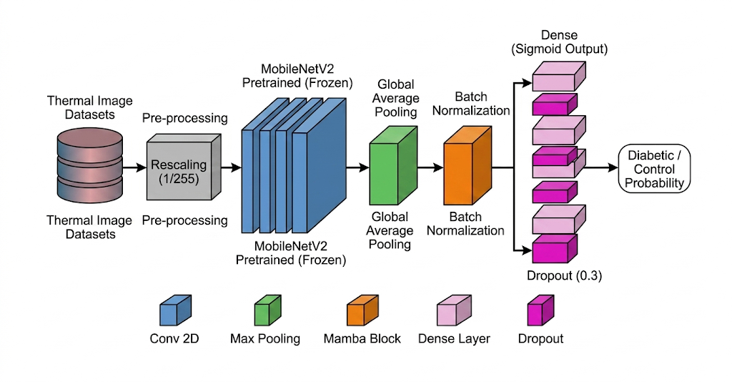
Fig 3.3.1 MobileNetV2 CNN Backbone Architecture
This deep learning convolution-based network was trained for two-class segregation between control and diabetic thermograms. RGB thermographic images and normalized pixel values were fed as input.
The feature extraction process involves the following steps:
- Transfer Learning:
The pre-trained CNN is loaded with weights learned from large datasets. Initial layers are kept frozen to retain general features such as edges and textures.
- Fine-Tuning:
Deeper layers of the network are selectively unfrozen and retrained on the thermal image dataset. This helps the model adapt to domain-specific features such as temperature variations and asymmetry patterns.
- Feature Map Generation:
As images pass through convolutional layers, the CNN generates feature maps that capture spatial relationships and thermal patterns present in the images.
- Embedding Extraction:
The output from the penultimate layer of the CNN is taken as a high-dimensional feature vector (embedding). These embeddings represent complex image characteristics in a compact numerical form.
These extracted deep features play a crucial role in identifying subtle thermal abnormalities associated with neuropathy. They are later combined with statistical thermal features to form a hybrid representation, improving the overall accuracy and robustness of the system.
3.4 Thermal Features Extraction
In addition to deep learning features, the proposed system extracts statistical thermal features from plantar thermograms to capture physiologically meaningful patterns associated with Diabetic Neuropathy. These features provide interpretability and help in understanding temperature variations caused by nerve dysfunction and poor blood circulation.
The thermal information is derived from the intensity component of the image, which represents temperature distribution across the foot. From this, several descriptive features are computed:
- Mean Temperature Intensity: Represents the average thermal value of the foot, indicating overall heat levels.
- Standard Deviation: Measures variation in temperature, highlighting uneven heat distribution.
- Entropy of Thermal Distribution: Captures randomness or disorder in temperature patterns, which may indicate abnormal physiological conditions.
- Minimum and Maximum Temperature: Identifies extreme thermal regions such as hotspots and coldspots.
- Temperature Range: Difference between maximum and minimum values, reflecting variability.
- Skewness: Indicates asymmetry in the temperature distribution.
- Hotspot and Coldspot Fractions: Represent regions with unusually high or low temperatures.
- Left–Right Thermal Asymmetry: Measures temperature differences between corresponding regions of both feet, a key indicator of neuropathy.
- Center–Periphery Temperature Difference: Compares heat distribution between central and outer regions of the foot.
To further quantify abnormal thermal behaviour, a composite Thermal Risk Score (TRS) is computed by combining selected features such as mean temperature, standard deviation, and entropy. This score reflects the severity of thermal irregularities.
3.5 Hybrid Features Representation
In order to improve the accuracy and robustness of the system for predicting Diabetic Neuropathy, a hybrid feature representation is adopted. This approach combines the strengths of both deep learning and statistical analysis by integrating CNN-based features with handcrafted thermal features.
From the CNN model such as MobileNetV2, high-dimensional feature vectors (embeddings) are extracted from the penultimate layer. These features capture complex spatial patterns, textures, and thermal variations present in the plantar images.
Simultaneously, statistical thermal features—such as mean temperature, entropy, asymmetry, and temperature distribution metrics—are computed to represent physiologically meaningful characteristics.
The hybrid representation is formed through feature fusion, where both feature sets are combined using concatenation:
- CNN Features: High-dimensional representations (e.g., 1280 features)
- Thermal Features: statistical descriptors (e.g., 12 features)
- Total Feature Vector: Combined feature space (e.g., 1292 features)
3.6 Dataset Risk Labelling and Thermal Risk Score
3.6.1 Thermal Risk Score
The Thermal Risk Score (TRS) is calculated by using a weighted equation of the mean, standard deviation, and entropy of the thermograms as follows:
where:
- is mean temperature value of the foot surface,
- is standard deviation in temperature over foot surface,
- is entropy showing thermal irregularity over foot surface.

Using Standard Scaler Thermal Risk Scores were converted to normal distribution before clustering was done.

3.6.2 K-Means clustering to divide data samples to risk categories
Unsupervised clustering was applied to TRS values of thermogram samples by using K-Means clustering. This was done with cluster count set to 3, random state set to 42, and initialization value of 20. Three clusters obtained were interpreted as Low, Medium and High Risk and categories were assigned based on cluster centroids, enabling data-driven stratification.

3.7 Risk Modelling and Classification

3.7.1 Risk Modelling Approach
The goal of this is to convert complex feature representations into a meaningful risk score and corresponding risk category. A machine learning model based on XGBoost is employed for risk modelling which works by combining multiple decision trees to minimize prediction error and improve accuracy.
In the proposed system for predicting Diabetic Neuropathy, risk modelling is performed using a regression-based approach. A gradient boosting regressor based on XGBoost is employed to map the hybrid feature representation into a continuous risk score.
This model must:
- Capture non-linear relationships between features
- Handle feature interactions efficiently
- Provide robust predictions even with complex data distributions
3.7.2 Regression based Risk Prediction
Instead of assigning discrete labels directly, the model predicts a continuous risk score. This design choice is important because:
- Neuropathy progression is gradual and continuous, not strictly categorical
- Regression allows modelling of subtle variations in severity
- It avoids rigid decision boundaries that may misclassify borderline cases

The predicted score is later mapped into ordinal categories (Low, Moderate, High) for clinical interpretation.

3.7.3 Input to the Model
The input to the XGBoost model is the hybrid feature vector:
- 1280-dimensional CNN embeddings (capturing spatial and texture patterns)
- 12 statistical thermal features (capturing physiological characteristics)
- Total input dimension: 1292 features
This rich feature representation enables the model to learn both data-driven patterns and domain-specific indicators.
3.7.4 Learning Mechanism and Model Architecture
XGBoost achieves learning through an ensemble of decision trees, where each tree iteratively corrects the errors of the previous ones using gradient boosting. The model learns by minimizing prediction error through iterative updates:
- Initial predictions are made using a simple model
- Subsequent trees are added to reduce residual errors
- Each iteration improves the overall prediction accuracy

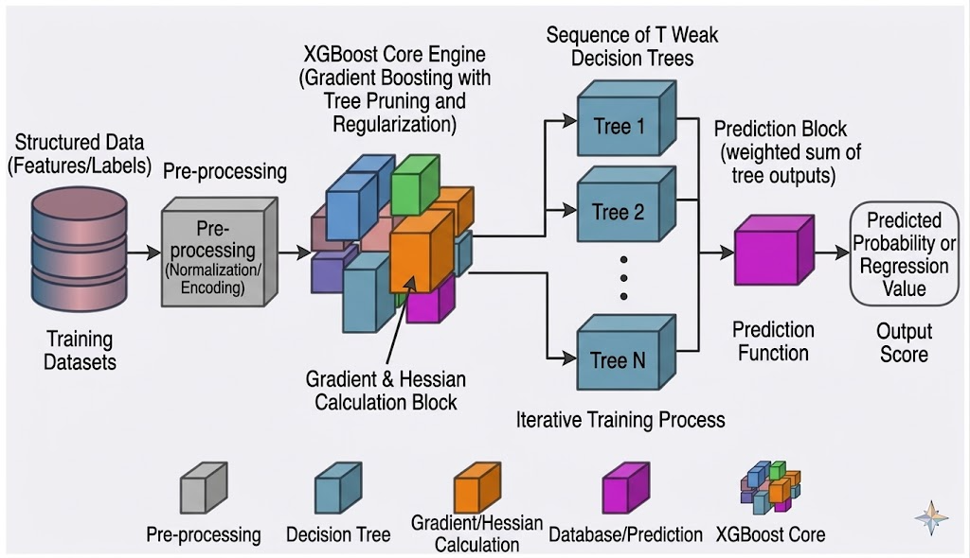
Fig 3.7.4.1 XGBoost Model Architecture

At each iteration, the XGBoost model minimizes following regularized objective function:
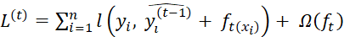
Here first term represents a differentiable convex loss function that measures the difference between the target and the prediction. XGBoost uses gradient, hessian of the loss function and second-order Taylor expansion, and optimizes wider range of objective functions other than standard squared error.

XGBoost model includes explicit regularization, which penalizes model complexity to prevent overfitting. It is defined as:
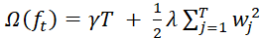
This term consists of two components:
Leaf Penalty (: This term penalizes total number of leaves in tree and hence controls model complexity.
Weight Scaling : This value keeps model more generalised and stable by smoothing out final learned weights with L2 regularisation.
4.4 Risk Score Interpretation
The continuous output is divided into three categories:
- Low Risk: 0.0 – 0.5
- Moderate Risk: 0.5 – 1.5
- High Risk: Greater than 1.5
The modelling process involves the following steps:
- Input Features:
The fused feature vector (combining CNN embeddings and thermal features) is used as input.

- Model Training:
The XGBoost model is trained on labelled data to learn relationships between features and neuropathy risk levels.
- Risk Score Prediction:
The model outputs a continuous risk score, representing the severity of neuropathy-related abnormalities.
- Risk Categorization:
o Low Risk (e.g., 0.0 – 0.5)
o Moderate Risk (e.g., 0.5 – 1.5)
o High Risk (> 1.5)
- Performance Evaluation:
The model is evaluated using metrics such as accuracy, confusion matrix, mean absolute error (MAE), and root mean square error (RMSE). These metrics help assess classification performance and prediction reliability.

3.8 Tools and Technologies
The implementation of the proposed system for predicting the risk of Diabetic Neuropathy is carried out using a well-integrated software and hardware environment that supports efficient development, experimentation, and model deployment. The choice of tools and technologies is based on factors such as performance, flexibility, scalability, and ease of use.

3.8.1 Programming Language: Python

Fig 3.8.1.1 Python

The entire system is developed using Python, which is widely recognized for its simplicity, readability, and extensive ecosystem for machine learning and data science. Python enables rapid prototyping and seamless integration of various libraries required for image processing, deep learning, and data analysis. Its large community support and availability of pre-built modules make it highly suitable for research-oriented projects.

3.8.2 Deep Learning Frameworks: TensorFlow and Keras

Fig 3.8.2.1 Tensorflow and Keras
TensorFlow and Keras are used as the core frameworks for designing and training Convolutional Neural Networks (CNNs). TensorFlow provides a robust backend for numerical computation and efficient execution on GPUs, while Keras offers a high-level interface that simplifies model building.

These frameworks allow:
- Easy implementation of pre-trained models such as MobileNetV2
- Support for transfer learning and fine-tuning
- Efficient handling of large-scale data and model training
- Built-in tools for monitoring training performance
3.8.3 Image Processing and Numerical Libraries: NumPy and OpenCV

Fig 3.8.3.1 NumPy

NumPy is used for efficient numerical computations, including matrix operations and array manipulations, which are essential for handling image data and feature vectors. It provides fast and memory-efficient operations required during preprocessing and feature extraction.


Fig 3.8.3.2 OpenCV
OpenCV is utilized for image processing tasks such as resizing, normalization, filtering, and transformation. It plays a crucial role in preparing thermal images for input into the CNN model. OpenCV also enables extraction of intensity-based features that represent temperature distributions in the images.
3.8.4 Machine Learning Utilities: Scikit-learn

Fig 3.8.4.1 Scikit-Learn

Scikit-learn is used for evaluating model performance and implementing additional machine learning utilities. It provides a wide range of tools for:
- Calculating performance metrics such as accuracy, precision, recall, F1-score, and AUC.
- Generating confusion matrices for classification analysis.
- Supporting preprocessing techniques like feature scaling and normalization.
These tools help in assessing the effectiveness and reliability of the proposed system.
3.8.5 Visualization Tools: Matplotlib
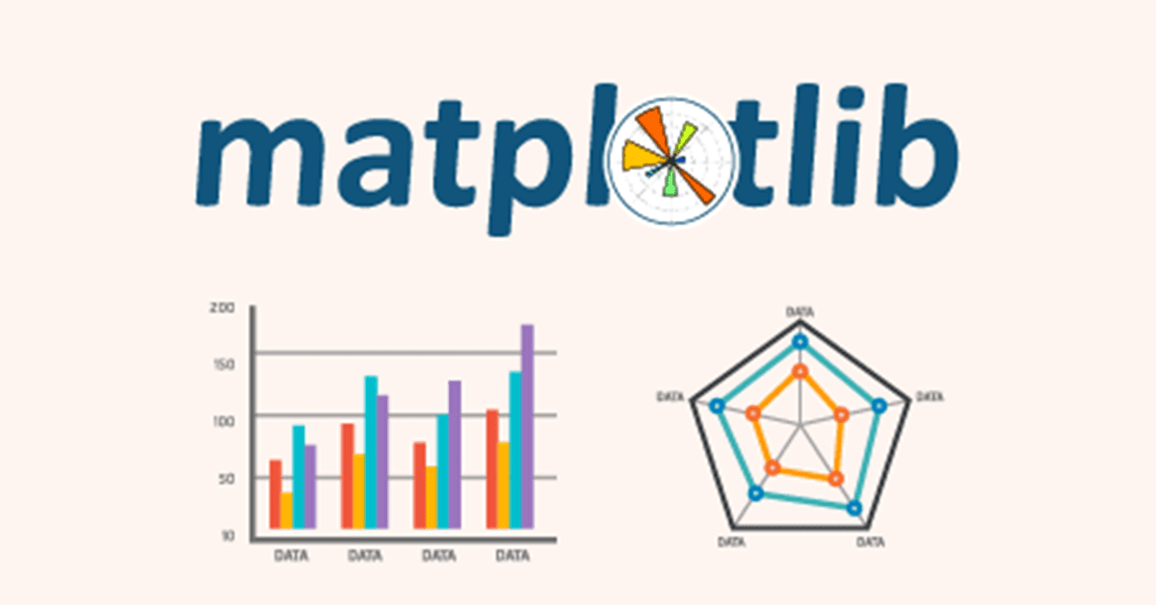
Fig 3.8.5.1 Matplotlib
Matplotlib is used to visualize various aspects of the training and evaluation process. It helps in plotting:

- Training and validation accuracy curves
- Loss graphs during model training
- Performance comparison between different models
Visualization aids in understanding model behaviour, detecting overfitting, and improving overall performance.
3.8.6 Development Platforms: Google Colab and Visual Studio Code


Fig 3.8.6.1 Google Colab
Google Colab is used for:
- Access to free GPU/TPU acceleration for faster model training
- Running large-scale experiments without requiring high-end local hardware
- Easy sharing and collaboration through cloud-based python-jupyter notebooks

Fig 3.8.6.2 Visual Studio Code
Visual Studio Code (VS Code) is used for:
- Writing, debugging, and organizing project code efficiently
- Managing local files, datasets, and project structure
- Running scripts and integrating various extensions for Python and machine learning
- Providing a customizable and user-friendly development environment
3.9 System Implementation
To demonstrate the practical applicability of the proposed system, a desktop-based user interface (UI) was developed for real-time diabetic neuropathy risk prediction using thermal foot images.
3.9.1 Application Structure
The desktop application is organized in a modular and maintainable structure, separating the user interface, model logic, and dependencies. The main project directory (App) contains the following components:

App (app.py) script – Main Application (UI Layer) - This is the entry point of the application.
- Creates the graphical user interface using Tkinter
- Handles user interactions such as image upload, heatmap visualization, and prediction
- Displays outputs including risk score, category, progress bar, and risk distribution graph
In short, App script manages the entire frontend and user experience.

2. Model (model.py) script – Model Inference Logic
This file contains the backend logic for prediction. It handles:
- Loading trained models (MobileNetV2 feature extractor, XGBoost regressor)
- Performing image preprocessing
- Extracting deep (CNN) and thermal features
- Applying feature scaling using StandardScaler
- Generating the final risk prediction score
This model script separates all ML-related operations from the UI, improving readability and maintainability.

3. Models directory – Trained Model Files
This directory stores all serialized trained components required at runtime:
- CNN feature extractor weights (MobileNetV2)
- XGBoost regression model
- StandardScaler object
Keeping these files in a dedicated folder allows easy updates or replacement of models without modifying the application code.

4. requirements.txt – Dependencies
This file lists all required Python libraries for the project, such as:
- TensorFlow / Keras (for CNN feature extraction)
- XGBoost (for regression model)
- Scikit-learn (for StandardScaler)
- OpenCV / PIL (for image processing)
- Matplotlib (for visualization)
- Tkinter (for GUI)
It ensures that the application can be reproduced and deployed easily in any environment.

5. __pycache__/ – Python Cache (Auto-generated)
This folder is automatically created by Python to store compiled bytecode (.pyc files).
- It improves execution speed
- It is not manually modified and can be ignored during development
This structure follows a separation of concerns principle:
- UI Layer (app.py) → Handles interaction and visualization
- Logic Layer (model.py) → Handles ML processing and predictions
- Data Layer (models/) → Stores trained artifacts
3.9.2 Machine and Deep Learning Models
The application loads the following trained components at runtime: a CNN-based feature extractor (MobileNetV2) for deep feature extraction, an XGBoost Regressor for risk prediction, and a StandardScaler for feature normalization consistent with the training pipeline.
3.9.3 User Interface
The desktop application is implemented using Python’s Tkinter library, providing a lightweight and efficient graphical interface. The window is fixed in size to ensure layout consistency and better usability. The interface consists of the following components:
- Title Header: Displays the application name “Diabetic Neuropathy Risk Predictor” with an icon for better visual identity.
- Image Display Panel: Shows the uploaded thermal foot image in a centered view.
- Upload Button: Allows users to select a thermal image (PNG/JPG format) from the system.
- See Heatmap Button: Enables visualization of the thermal distribution (heatmap) of the uploaded image for better interpretability.
- Predict Button: Initiates the risk prediction process.
- Result Display Area: Shows the predicted risk category (Low/Medium/High) along with the numerical risk score, color-coded for clarity.
- Progress Bar Indicator: Provides a visual representation of the predicted risk score along a continuous scale.
- Risk Distribution Graph: Displays a horizontal band-based visualization dividing risk into Low, Medium, and High regions using color-coded zones. A dashed horizontal line indicates the predicted score position within this distribution, improving interpretability.

3.9.4 Application Workflow
The application operates through the following steps:
- Image Upload:
The user selects a thermal foot image using the file dialog interface. The selected image is displayed in the image panel.
- Preprocessing and Feature Extraction:
The input image is processed through the hybrid feature extraction pipeline:
  - CNN embeddings (1280 deep features) are extracted using MobileNetV2
  - Thermal features (12 handcrafted descriptors) are computed
- Feature Scaling:
The combined feature vector is normalized using a pre-trained StandardScaler to match the training distribution.
- Risk Prediction:
The normalized features are passed to the XGBoost regressor, which outputs a continuous risk score.
- Risk Mapping:
The predicted score is categorized into:
  - Low Risk: ≤ 0.5
  - Medium Risk: 0.5 – 1.5
  - High Risk: > 1.5
- Output Visualization:
The system presents results through multiple visual elements:
  - The predicted risk category and score are displayed prominently
  - A progress bar provides an immediate sense of severity
  - A risk distribution graph shows where the score lies relative to predefined risk zones
  - An optional heatmap visualization helps interpret thermal patterns in the input image

3.9.5 Implementation Screenshots
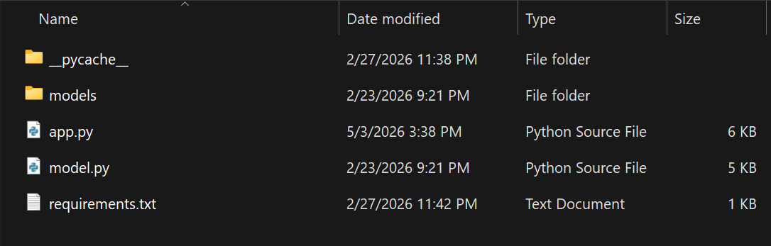
Fig 3.9.5.1 Overall Application Structure containing models and scripts
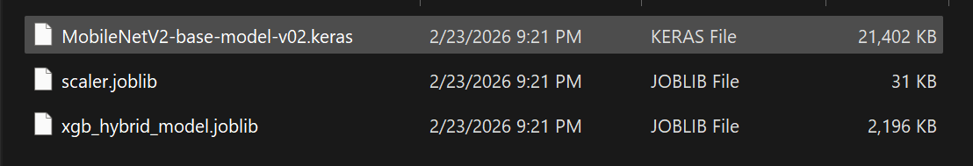
Fig 3.9.5.2 Models directory containing trained MobileNetV2, XGBoost models and StandardScaler artifact
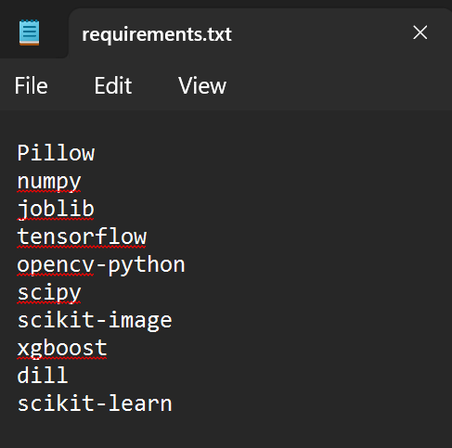
Fig 3.9.5.3 Requirements file for setting up environment for the application
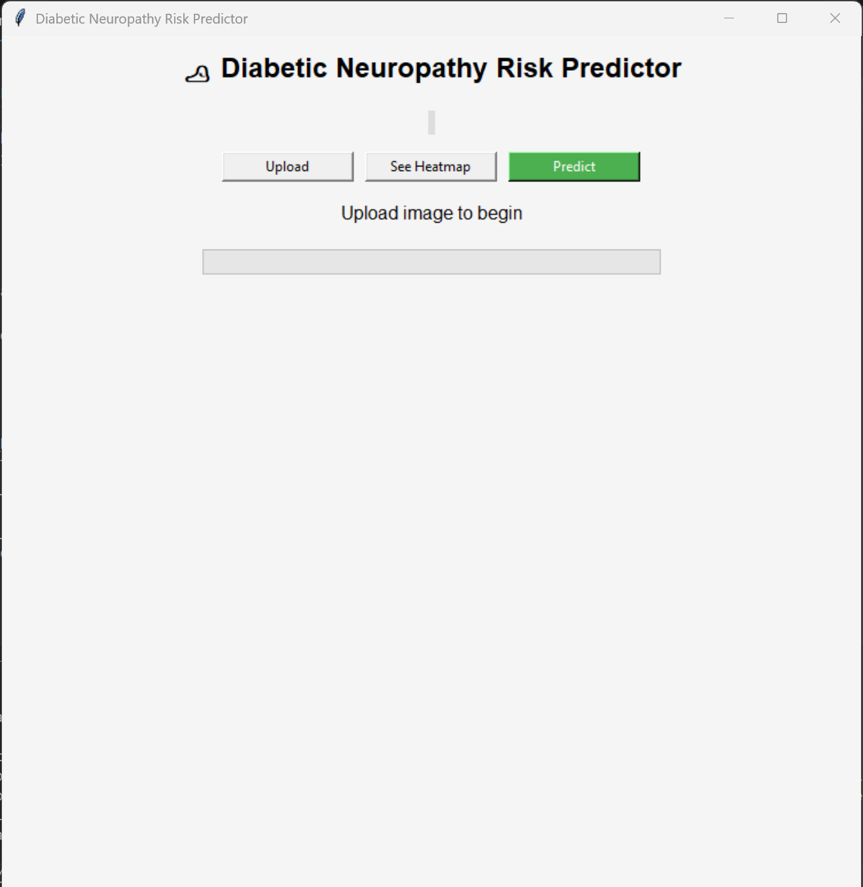
Fig 3.9.5.4 Opening Interface of the Diabetic Neuropathy Risk Predictor Application
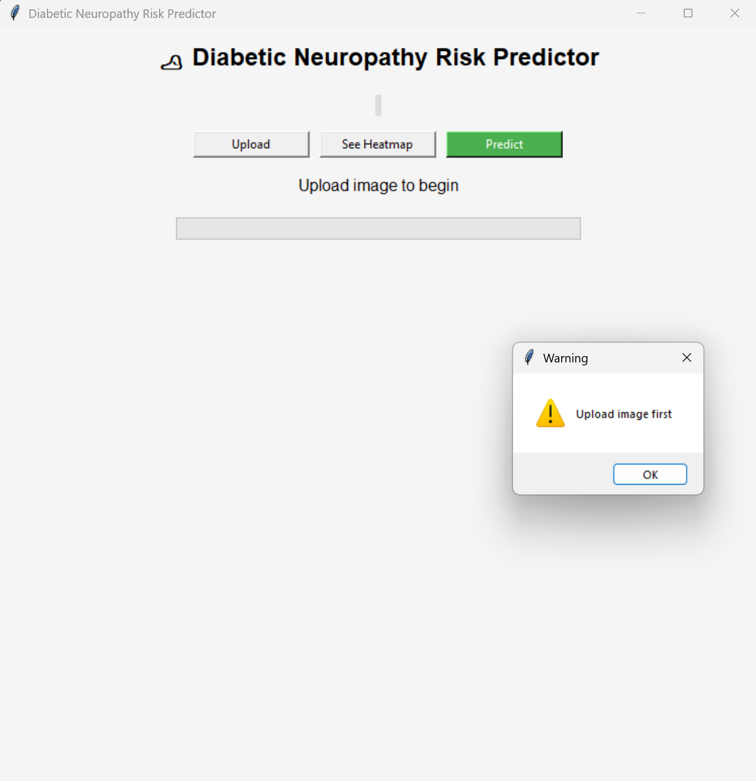
Fig 3.9.5.5 Application giving a warning message for using predict option when no images are uploaded
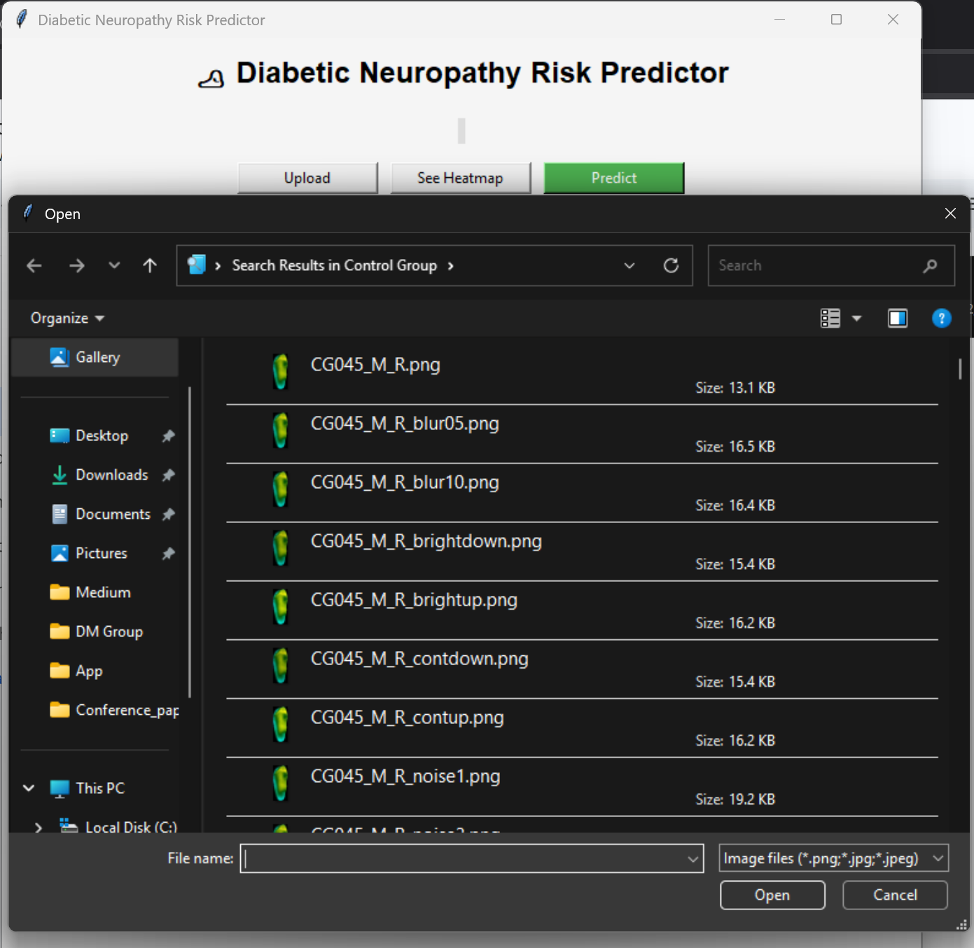
Fig 3.9.5.6 Thermal image file selection menu after pressing the upload button in Application
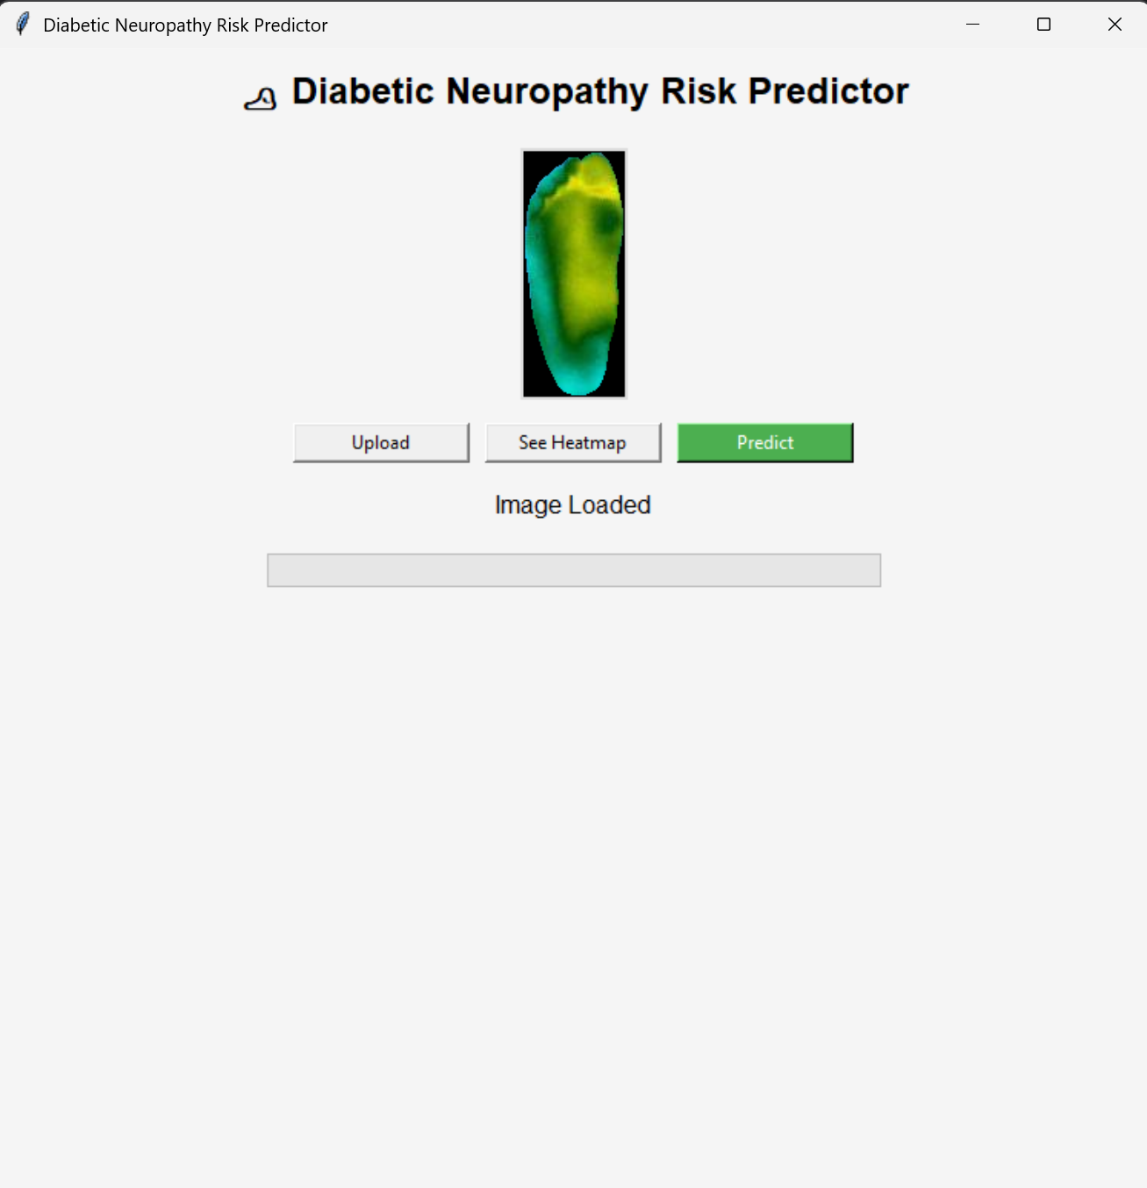
Fig 3.9.5.7 Application interface showing uploaded image preview
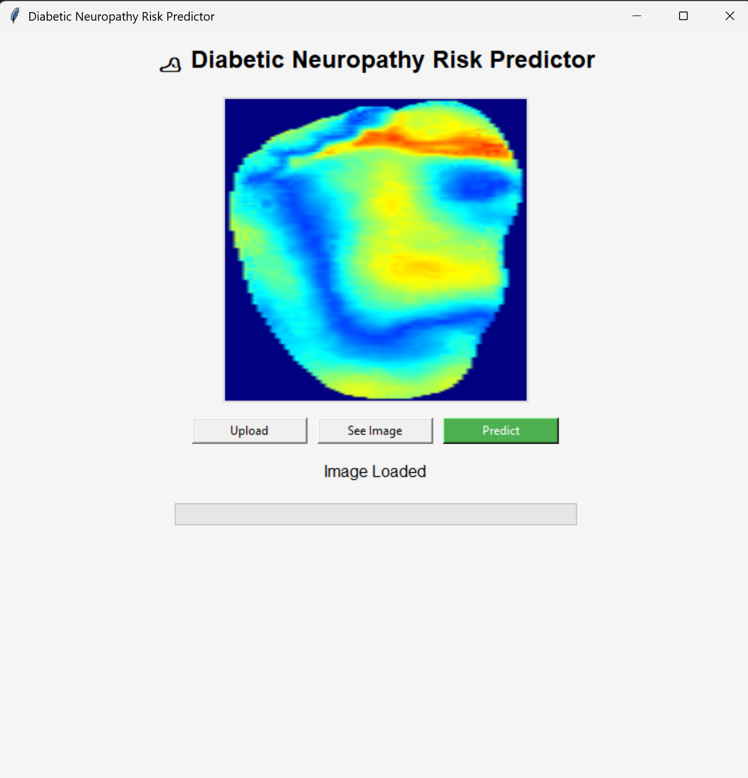
Fig 3.9.5.8 Application interface showing uploaded image preview as heatmap
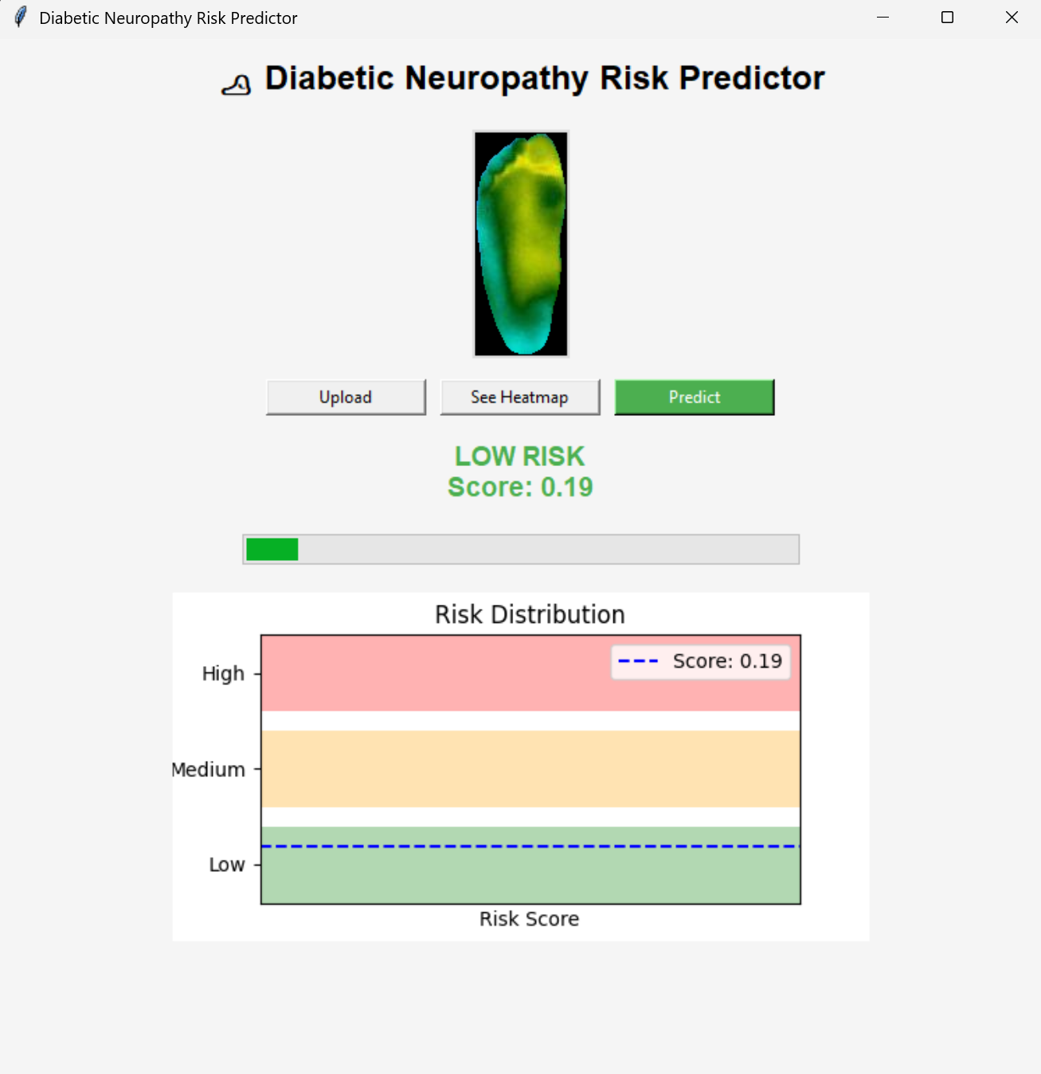
Fig 3.9.5.9 Application showing prediction output with colour highlighted text, progress bar, and a color graph for Low Risk category image
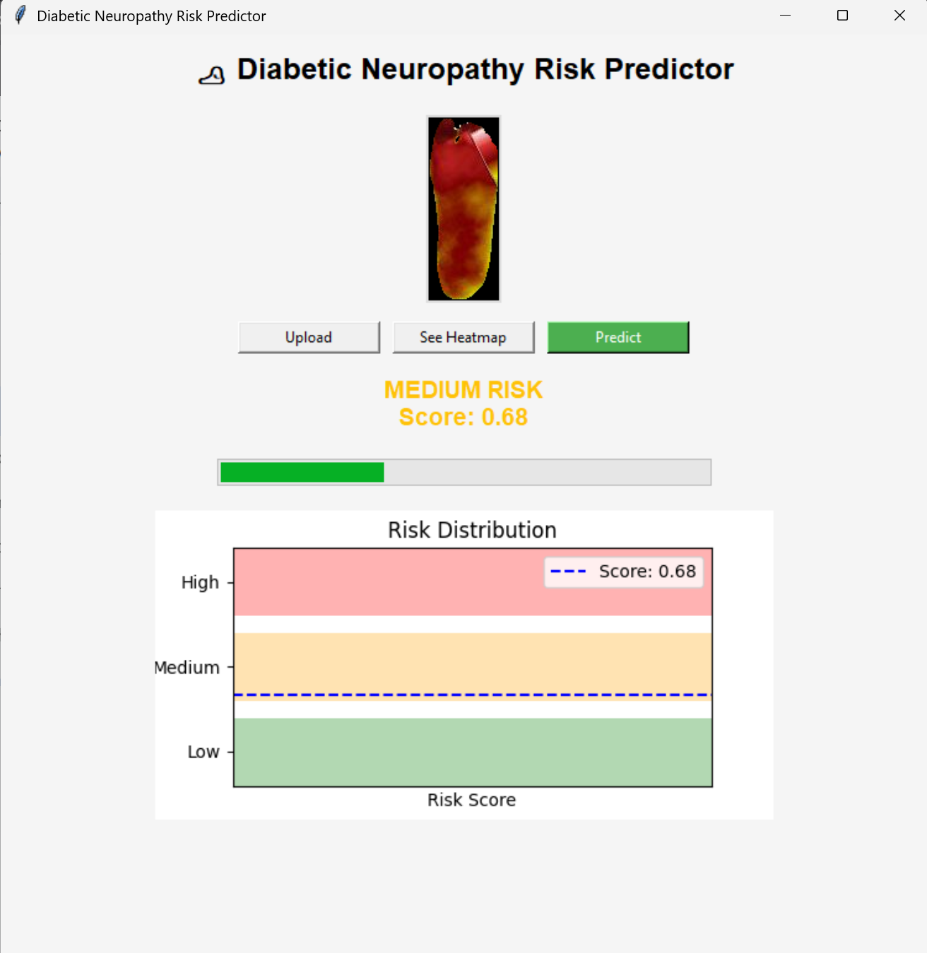
Fig 3.9.5.10 Application showing prediction output with colour highlighted text, progress bar, and a color graph for Medium Risk category image
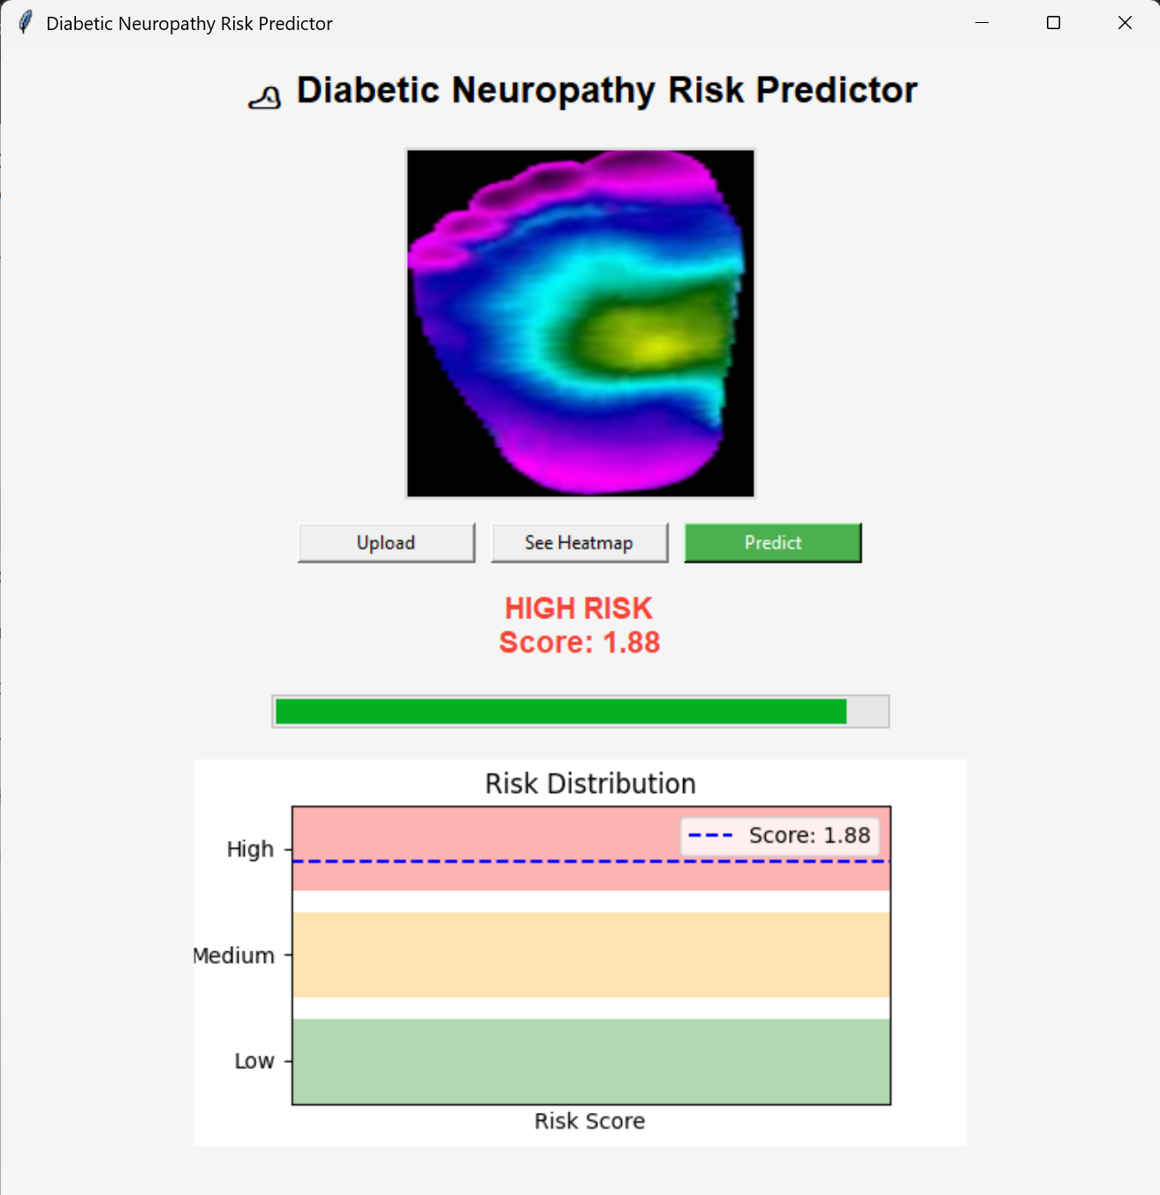
Fig 3.9.5.11 Application showing prediction output with colour highlighted text, progress bar, and a color graph for High Risk category image

CHAPTER 4
RESULTS AND DISCUSSIONS
This chapter presents the experimental results and analysis of the proposed system for predicting the risk of Diabetic Neuropathy using thermal foot image analysis. The performance of the system is evaluated across multiple stages as follows.
4.1 CNN Model Performance Results
This section evaluates the performance of different Convolutional Neural Network (CNN) architectures used for feature extraction in the proposed system for predicting risk of Diabetic Neuropathy. The models considered include EfficientNet variants and MobileNetV2, all trained using transfer learning. Multiple CNN Backbones were trained and tested and MobileNetV2 was the chosen model.

Models | Accuracy | Precision | Recall | F1-Score | AUC | NPV | Loss
EfficientNet-B0 (Norm) | 0.7951 | 0.7924 | 0.8899 | 0.8383 | 0.8546 | 0.8004 | 0.4984
EfficientNet-B0 | 0.8974 | 0.9162 | 0.9116 | 0.9139 | 0.9682 | 0.8699 | 0.2584
EfficientNet-B1 | 0.8870 | 0.9303 | 0.8764 | 0.9026 | 0.9543 | 0.8313 | 0.2624
MobileNetV2 | 0.9145 | 0.9234 | 0.9343 | 0.9288 | 0.9782 | 0.9010 | 0.2539

Table 4.1 Comparison of performance of different Pre-trained CNN backbones.

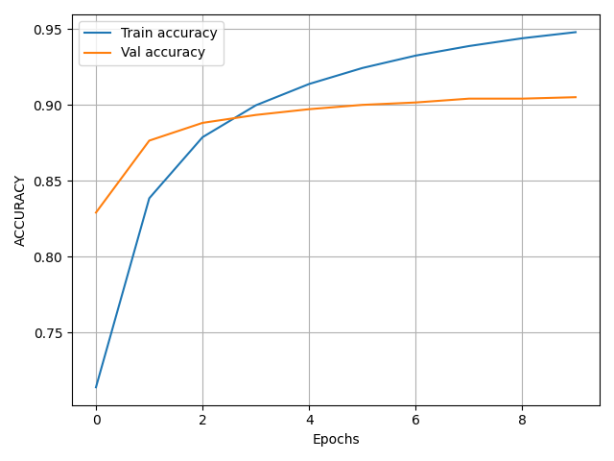
Fig 4.1.1 Accuracy Plots of Training of MobileNetV2 based Classifier Model.
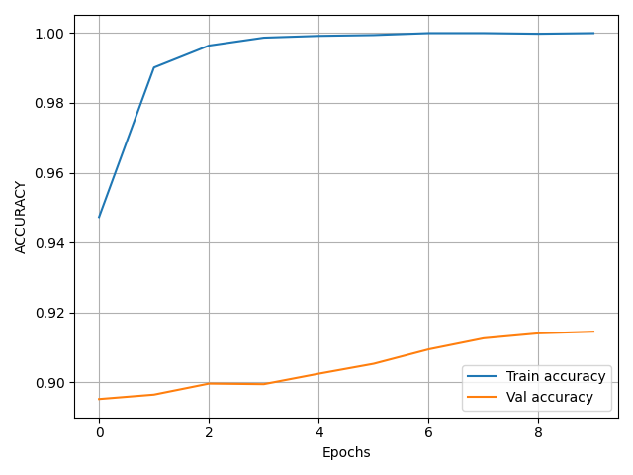
Fig 4.1.2 Accuracy Plots of Fine Tuning of MobileNetV2 based Classifier Model.

4.2 Dataset Risk Labelling Analysis
This section analyses the method used to generate risk labels for the dataset in the proposed system for predicting Diabetic Neuropathy. Instead of relying on manual annotation, an unsupervised thermal analysis approach was adopted to ensure objectivity and consistency in labelling.

4.2.1 Thermal Feature-Based Labelling
Each thermographic image was processed to extract physiologically meaningful temperature descriptors. The thermal information was derived from the V (intensity) channel of the HSV color space, which serves as a proxy for temperature distribution.
The following key features were computed:
4.2.1.1 Mean Temperature Intensity
The mean temperature represents the average thermal intensity across the entire plantar region of the foot.
- In healthy individuals, the temperature distribution is generally uniform and balanced.
- In neuropathy cases, abnormal blood flow and inflammation can lead to elevated or reduced average temperatures.
- A higher mean temperature may indicate localized inflammation or infection, while lower values may suggest poor circulation.
4.2.1.2 Standard Deviation of Temperature
Standard deviation measures the variation or spread of temperature values across the foot.
- Low standard deviation indicates uniform heat distribution, typical of healthy tissue.
- High standard deviation reflects uneven temperature patterns, often caused by nerve damage or vascular issues.
For example, hotspots (high temperature regions) and coldspots (low temperature regions) increase variability.

4.2.1.3 Entropy of Thermal Distribution
Entropy quantifies the degree of randomness or disorder in the thermal image.
- Low entropy corresponds to organized and consistent temperature patterns.
- High entropy indicates irregular and chaotic heat distribution, which is often associated with neuropathic conditions.
In thermal imaging:
- Healthy feet show structured patterns
- Neuropathic feet show disrupted and unpredictable patterns

4.2.1.4 Left–Right Thermal Asymmetry
This feature measures the temperature difference between corresponding regions of the left and right feet.
- In normal conditions, both feet exhibit symmetrical thermal patterns.
- In neuropathy, nerve damage and impaired blood flow cause significant asymmetry between the two feet.
For example:
- One foot may show higher temperature due to inflammation
- The other may show lower temperature due to reduced circulation
4.2.2 Thermal Risk Score (TRS)
The Thermal Risk Score (TRS) is a composite metric designed to quantify the severity of thermal abnormalities observed in plantar thermograms for assessing Diabetic Neuropathy. Instead of relying on a single feature, TRS integrates multiple physiologically meaningful descriptors into a unified score that reflects overall neuropathic risk.
4.2.2.1 TRS Formulation
The three features used in TRS capture complementary aspects of thermal behaviour:
- Mean Temperature (40%)
Represents the overall heat level of the foot. Elevated mean temperature is often associated with inflammation, while reduced temperature may indicate poor circulation.
- Standard Deviation (30%)
Measures how uneven the temperature distribution is. High variability suggests the presence of localized abnormalities such as hotspots and coldspots.
- Entropy (30%)
Reflects the randomness or disorder in the thermal pattern. Increased entropy indicates abnormalities.
4.2.2.3 Interpretation of TRS Values
The TRS provides a continuous measure of abnormality, where:
- Low TRS: Indicates uniform temperature distribution and symmetry and likely healthy condition.
- Moderate TRS: Suggests mild irregularities and possible early-stage neuropathy.
- High TRS: Reflects significant thermal abnormalities and high neuropathic risk.
Higher TRS values correspond to greater deviation from normal physiological patterns.
4.2.2.4 Role of TRS in Risk Labelling
TRS plays a central role in the unsupervised labelling process:
- TRS is computed for each image
- K-Means clustering groups images based on feature similarity
- Clusters are ranked according to their average TRS values
- Risk labels (Low, Moderate, High) are assigned based on TRS ranking
4.2.2.5 Unsupervised Risk Grouping
To avoid subjective threshold selection, K-Means clustering with number of clusters set to 3, random state set to 42 was applied to thermal risk scores for images. The clustering process then groups images into three natural clusters corresponding to different risk levels.
- Clusters are ranked based on average TRS values
- Risk labels (Low, Moderate, High) are assigned in ascending order of TRS
4.3 Risk Prediction Results

Actual / Predicted | Low | Medium | High
Low | 1489 | 545 | 13
Medium | 200 | 2224 | 172
High | 18 | 679 | 990

Table 4.3.1 Confusion Matrix for results of XGBoost model for hybrid input features

Root Mean Square Error (RMS) | 0.473100
Mean Absolute Error (MAE) | 0.357319
Ordinal Accuracy (±1 tolerance) | 0.995102

Table 4.3.2 Performance metrics for results of XGBoost model for hybrid input features

1. Low Risk Category
- Correctly classified: 1489 samples
- Misclassified as Medium: 545 samples
- Misclassified as High: 13 samples
2. Moderate Risk Category
- Correctly classified: 2224 samples
- Misclassified as Low: 200 samples
- Misclassified as High: 172 samples
3. High Risk Category
- Correctly classified: 990 samples
- Misclassified as Medium: 679 samples
- Misclassified as Low: 18 samples
Key Observations :
- Strong Separation of Extreme Classes :
Very few samples are misclassified directly between Low and High categories, indicating that the model effectively distinguishes clearly different risk levels.
- Adjacent Class Overlap :
Most errors occur between neighbouring classes (Low–Medium and Medium–High), which is expected in ordinal classification problems.
To evaluate the contribution of handcrafted thermal features, an additional experiment was conducted using only CNN-based embeddings without incorporating global thermal descriptors. This experiment was performed based on evaluator feedback to compare the effectiveness of deep features alone against the proposed hybrid feature representation.

The same dataset, preprocessing pipeline, and train-validation split were retained to ensure a fair comparison with 21,660 training samples and 6,330 validation samples. The CNN encoder (MobileNetV2) was used to extract deep feature embeddings from thermographic images. CNN extracted feature vector has 1280 features and this setup relies purely on learned spatial representations from the CNN.
These extracted CNN embeddings were used to train an XGBoost regressor under the same configuration as the hybrid model.
Actual / Predicted | Low | Medium | High
Low | 825 | 1180 | 42
Medium | 255 | 1984 | 357
High | 11 | 977 | 699

Table 4.3.3 Confusion Matrix for results of XGBoost model for CNN-only input features

Root Mean Square Error (RMS) | 0.610200
Mean Absolute Error (MAE) | 0.498862
Ordinal Accuracy (±1 tolerance) | 0.991627

Table 4.3.4 Performance metrics for results of XGBoost model for CNN-only input features

4.3.1 Comparative Analysis
When compared to the hybrid feature model (CNN + thermal features), the CNN-only model demonstrates:

- Higher error metrics, indicating reduced prediction accuracy.
- The relatively higher RMSE (0.6102) and MAE (0.4989) indicate reduced precision in risk estimation when compared to the hybrid model.
- Less balanced classification across risk categories
Metrics | CNN Features only Model | Hybrid Features Model
Root Mean Square Error (RMS) | 0.610200 | 0.473100
Mean Absolute Error (MAE) | 0.498862 | 0.357319
Ordinal Accuracy (±1 tolerance) | 0.991627 | 0.995102

Table 4.3.1.1 Comparing performance of XGBoost model with inputs having CNN features only and Hybrid features
In contrast, the hybrid model benefits from combining deep learned features with domain-specific thermal descriptors, resulting in:
- Improved separation between risk classes
- Better alignment with physiological characteristics of neuropathy
- More reliable and clinically meaningful predictions
This experiment confirms that while CNN embeddings capture important spatial patterns, they are not sufficient alone for precise neuropathy risk estimation. The inclusion of handcrafted thermal features significantly enhances model performance and interpretability.

4.3.2 Performance Metrics Analysis
4.3.2.1 Root Mean Square Error (RMSE)
RMSE measures the square root of the average squared difference between predicted and actual risk scores.
- A value of 0.4731 indicates that predictions are, on average, close to the true values.
- RMSE penalizes larger errors more heavily, making it sensitive to significant deviations.
- The relatively low RMSE suggests that the model rarely makes large prediction errors.
- This is important in medical applications where extreme misclassification must be minimized.
4.3.2.2 Mean Absolute Error (MAE)
MAE calculates the average absolute difference between predicted and actual values.
- A value of 0.3573 indicates that the average prediction error is small.
- Unlike RMSE, MAE treats all errors equally.
- The low MAE confirms that predictions are consistently close to actual values.
- It provides a clear and interpretable measure of average model error
4.3.2.3 Ordinal Accuracy (±1 Tolerance)
Ordinal accuracy measures the percentage of predictions that fall within the correct category or an adjacent category.
- A value of 0.9951 (99.51%) indicates good accuracy
- Predictions are almost always correct or off by only one category

CHAPTER 5
CONCLUSIONS
This project presented a Model-based Thermal Risk Score (TRS) framework for the classification of Diabetic Neuropathy using infrared thermograms of the sole of the foot. Unlike traditional approaches that rely on simple binary classification or fixed temperature thresholds, the proposed method integrates deep learning, image-based feature extraction, and unsupervised clustering to achieve a more structured and meaningful risk classification system.
Through evaluation on an augmented dataset, it is observed that thermal images alone are insufficient to provide highly reliable classification results. However, when thermal features extracted from the images are combined with deep learning-derived features, the overall prediction performance improves significantly. This hybrid approach offers a more robust and reliable model compared to standard CNN-only based systems, as it better captures complex patterns within the dataset.
Furthermore, the framework enables a continuous risk scoring mechanism rather than limiting the output to binary labels. This makes it more suitable for monitoring the progression of neuropathic changes over time. By adapting to underlying data distributions, the model provides a more flexible and clinically meaningful representation of risk levels.
However, the study is limited to thermal imaging data alone and does not incorporate additional patient biomarkers or clinical parameters that may further improve prediction accuracy. In addition, the clustering-based interpretation of risk is sensitive to dataset distribution and may require further calibration and validation across larger and more diverse datasets.
Overall, the proposed framework demonstrates that combining deep learning with feature-based analysis and clustering techniques can effectively support non-invasive diabetic neuropathy risk classification using thermal imaging of the foot soles.

APPENDIX A
Project Title | A data-driven framework for diabetic peripheral neuropathy risk prediction using foot thermograms
USN | Team Members | Email ID | Mobile  number
02JST22UCS006 | Agasthya Samyak Jnan | agasthyasamyakjnan5577@gmail.com | 9606519615
02JST22UCS043 | Jayanth S | jayanth7m@gmail.com | 9036888930
02JST22UCS017 | Arvind Ningombam | ningombamarvind@gmail.com | 6009759628
01JST21CS099 | Prajwal T P | prajwaltp06@gmail.com | 8147737978


Agasthya Samyak Jnan Jayanth S

Arvind Ningombam Prajwal T P

APPENDIX B
Mapping for the project work (22CS83P)
Course Outcomes:
CO1: Formulate the problem definition, conduct literature review and apply requirements analysis.
CO2: Develop and implement algorithms for solving the problem formulated.
CO3: Comprehend, present and defend the results of exhaustive testing and explain the major findings.

Program Outcomes:
PO1: Apply knowledge of computing, mathematics, science, and foundational engineering concepts to solve computer engineering problems.
PO2: Identify, formulate and analyze complex engineering problems.
PO3: Plan, implement and evaluate a computer-based system to meet desired societal needs such as economic, environmental, political, healthcare and safety within realistic constraints.
PO4: Incorporate research methods to design and conduct experiments to investigate real-time problems, to analyze, interpret and provide feasible conclusions.
PO5: Propose innovative ideas and solutions using modern tools.
PO6: Apply computing knowledge to assess societal, health, safety, legal and cultural issues and the consequent responsibilities relevant to professional engineering practice. PO7: Analyze the local and global impact of computing on individuals and organizations for sustainable development.
PO8: Adopt ethical principles and uphold the responsibilities and norms of computer engineering practice.
PO9: Work effectively as an individual and as a member or leader in diverse teams and in multidisciplinary domains.
PO10: Effectively communicate and comprehend.

PO11: Demonstrate and apply engineering knowledge and management principles to manage projects in multidisciplinary environments.
PO12:Recognize contemporary issues and adapt to technological changes for lifelong learning.

Program Specific Outcomes:
PSO1: Problem Solving Skills: Ability to apply standard practices and mathematical methodologies to solve computational tasks, model real world problems in the areas of machine learning systems, system software and computer vision solutions with an appropriate knowledge of Data structures and Algorithms.
PSO2: Knowledge of Computer Systems: An understanding of the structure and working of the computer systems with performance study of various computing architectures.
PSO3: Successful Career and Entrepreneurship: The ability to get acquainted with the state-of-the-art software technologies leading to entrepreneurship and higher studies.
PSO4: Computing and Research Ability: Ability to use knowledge in various domains to identify research gaps and to provide solutions to new ideas leading to innovations.
Justification for CO-PO and PSO mapping
In our Final Year Project (FYP), we have addressed several Course Outcomes (COs), Program Outcomes (POs), and Program Specific Outcomes (PSOs) through the development and implementation of our Diabetic Neuropathy Risk Predictor Application.
Course Outcomes:
CO1: Formulate the problem definition, conduct literature review and apply requirements analysis.
- The report clearly outlines the problem definition of the diabetic neuropathy risk predictor project and conducts a literature review by discussing various algorithms and technologies used in thermal foot image analysis.
- Requirements analysis is demonstrated through the discussion of system requirements, functional and non-functional requirements.

CO2: Develop and implement algorithms for solving the problem formulated - The report details the development and implementation of algorithms for deep feature extraction from thermal foot images and risk prediction based on hybrid combined features, specifically highlighting the integration of CNN-based deep learning with XGBoost based regression learning for diabetic neuropathy risk prediction.
- Results of testing of algorithms are presented, demonstrating the effectiveness and efficiency of the algorithms in predicting diabetic neuropathy risk.
CO3: Comprehend, present and defend the results of exhaustive testing and explain the major findings
- Exhaustive testing of the image feature extraction and risk prediction algorithms are conducted and results are presented in the report, including quantitative metrics such as precision, recall, and F1 score.
- The major findings of the testing, including the efficiency and insightful content of the summaries, are explained and discussed in detail.
Program Outcomes:
PO1: Apply knowledge of computing, mathematics, science, and foundational engineering concepts to solve computer engineering problems
- The project applies knowledge of computing concepts, algorithms, and data structures to develop algorithms for news summarization.
- Mathematical and statistical techniques are utilized in the neuropathy risk prediction process, such as CNN-based feature extraction and feature fusion.
PO3: Plan, implement and evaluate a computer-based system to meet desired societal needs such as economic, environmental, political, healthcare and safety within realistic constraints
- The diabetic neuropathy risk predictor project addresses the societal need for efficient access to relevant assessment of their conditions by providing an effective risk assessment tool.
- The system is implemented to meet realistic constraints such as scalability, security, and user interface design.
PO4: Incorporate research methods to design and conduct experiments to investigate real-time problems, to analyze, interpret and provide feasible conclusions.
- The project incorporates research methods by conducting experiments to evaluate the effectiveness of deep image features extraction and risk prediction algorithms.
- Feasible conclusions are drawn based on the results of testing and analysis, informing further improvements to the system.

Program Specific Outcomes:
PSO1: Problem Solving Skills: Ability to apply standard practices and mathematical methodologies to solve computational tasks, model real world problems in the areas of machine learning systems, system software and computer vision solutions with an appropriate knowledge of Data structures and Algorithms.
- The project demonstrates problem-solving skills by applying standard practices and algorithms to solve the computational task of extracting meaningful representation of medical images.
- Mathematical methodologies such as gradient boosting and convolution based neural networks are used to model real-world problems in image feature extraction and representations.
PSO2: Knowledge of Computer Systems: An understanding of the structure and working of the computer systems with performance study of various computing architectures.
- The project showcases an understanding of computer systems by implementing a combination of machine and deep learning frameworks.
- Performance study of machine and deep learning algorithms is conducted to evaluate the effectiveness and efficiency of the system.
PSO4: Computing and Research Ability: Ability to use knowledge in various domains to identify research gaps and to provide solutions to new ideas leading to innovations.
- The project demonstrates computing and research ability by identifying the need for efficient feature extraction from images and proposing innovative solutions using advanced algorithms and technologies.
Table of Mapping of CO, PO and PSO:
SUBJECT | CODE | CO | PO1 | PO2 | PO3 | PO4 | PO5 | PO6 | PP P  O  7  OO | PO8 | P  O  9 | PO  10 | PO  11 | P  O  12 | Pspssssssssssssssss P  S  O  1 | P  S  O  2 | P  S  O  3 | P  SO  4
Project Work | 22CS83P | CO1 | 3 | 2 | 1 | 2 | 2 | 2 | 1 | 2 | 3 | 2 | 1 | 1 | 1 | 3 | 3 | 2
 |  | CO2 | 3 | 3 | 2 | 2 | 3 | 2 | 1 | 3 | 3 | 3 | 3 | 3 | 3 | 3 | 1 | 3
 |  | CO3 | 3 | 2 | 2 | 3 | 2 | 2 | 1 | 3 | 3 | 3 | 1 | 2 | 3 | 3 | 1 | 3

Note:
Scale
0 – Not Applicable
1 – Low relevance Scale
2 – Medium relevance Scale
3 – High relevance Scale

REFERENCES
[1] L. A. Lavery, D. G. Armstrong, D. P. Wunderlich, J. Tredwell, and A. J. M. Boulton, “Home monitoring of foot skin temperatures to prevent ulceration,” Diabetes Care, vol. 27, no. 11, pp. 2642–2647, 2004.
[2] S. Bagavathiappan, J. Philip, T. Jayakumar, et al., “Correlation between plantar foot temperature and diabetic neuropathy: a case study using infrared thermal imaging,” Journal of Diabetes Science and Technology, vol. 4, no. 6, pp. 1386–1392, 2010.
[3] L. F. Balbinot, M. A. Canani, L. H. Robinson, et al., “Repeatability of infrared plantar thermography in diabetes patients: a pilot study,” Journal of Diabetes Science and Technology, vol. 7, no. 5, pp. 1130–1137, 2013.
[4] L. R. J. van Netten, J. J. van Baal, L. Liu, et al., “Infrared thermal imaging for automated detection of diabetic foot complications,” Journal of Diabetes Science and Technology, vol. 7, no. 5, pp. 1122–1129, 2013.
[5] D. Hernández-Contreras, H. Peregrina-Barreto, J. Rangel-Magdaleno, and F. Renero Carrillo, “Infrared thermography dataset for diabetic foot analysis,” IEEE DataPort, 2019. Available: IEEE DataPort.
[6] A. Khandakar, M. E. H. Chowdhury, M. B. I. Reaz, et al., “Thermal change index based diabetic foot thermogram image classification using machine learning techniques,” Sensors, vol. 22, no. 5, p. 1793, 2022.
[7] R. Castillo-Morquecho, E. Guevara, J. L. Ramírez-GarcíaLuna, et al., “Digital infrared thermography and machine learning for diabetic foot assessment,” Journal of Diabetes & Metabolic Disorders, vol. 23, 2024.
[8] L. Wu, R. Huang, X. He, L. Tang, and X. Ma, “Advances in machine learning-aided thermal imaging for early detection of diabetic foot ulcers: a review,” Biosensors, vol. 14, no. 12, 2024.
[9] M. Sandler, A. Howard, M. Zhu, A. Zhmoginov, and L.-C. Chen, “MobileNetV2: Inverted residuals and linear bottlenecks,” in Proc. IEEE Conf. Computer Vision and Pattern Recognition (CVPR), 2018, pp. 4510–4520.
[10] T. Chen and C. Guestrin, “XGBoost: A scalable tree boosting system,” in Proc. ACM SIGKDD Int. Conf. Knowledge Discovery and Data Mining, 2016, pp. 785–794.
[11] C. Shorten and T. M. Khoshgoftaar, “A survey on image data augmentation for deep learning,” Journal of Big Data, vol. 6, p. 60, 2019.
[12] A. J. M. Boulton, L. Vileikyte, G. Ragnarson-Tennvall, and J. Apelqvist, “The global burden of diabetic foot disease,” The Lancet, vol. 366, no. 9498, pp. 1719–1724, 2005.
[13] J. Apelqvist, K. Bakker, W. H. van Houtum, et al., “International consensus and practical guidelines on the management and prevention of the diabetic foot,” Diabetes/Metabolism Research and Reviews, 2000.
[14] A. Bharara, J. Cobb, and D. G. Armstrong, “Plantar foot temperature monitoring in the diabetic population: a review,” Journal of Diabetes Science and Technology, vol. 1, no. 4, pp. 564–571, 2007.
[15] J. Yavuz, W. L. Smith, and L. A. Lavery, “Temperature monitoring to assess, predict, and prevent diabetic foot complications,” Current Diabetes Reports, vol. 15, no. 9, 2015.
[16] D. G. Armstrong, L. A. Lavery, and S. A. Harkless, “Validation of a diabetic wound classification system,” Diabetes Care, vol. 21, no. 5, pp. 855–859, 1998.
[17] M. Goyal, D. Reeves, S. Rajbhandari, et al., “Evaluation of thermal imaging in diabetic foot ulceration,” Diabetes Care, 2010.
[18] L. Seixas, M. Nery, and C. P. Monteiro, “Relationship between skin temperature and tissue characteristics in diabetic patients,” Physiological Measurement, 2019.
[19] B. Jeffcoate and K. Harding, “Diabetic foot ulcers,” The Lancet, vol. 361, no. 9368, pp. 1545–1551, 2003.
[20] International Working Group on the Diabetic Foot (IWGDF), “Guidelines on the prevention and management of diabetic foot disease,” IWGDF Guidelines, 2019.

